B. Tech Project Report

On

Investigation of Dislocation Density of Directed Energy Deposited 316L Steel at Elevated Temperatures.

BY

Jaya Vardhan



Discipline of Metallurgical Engineering and Materials Science

Indian Institute of Technology Indore

2024

Investigation of Dislocation Density of Directed Energy Deposited 316L Steel at Elevated Temperatures.

**A PROJECT REPORT**

*Submitted in partial fulfilment of the*

*requirements for the award of the degrees*

***of***

**BACHELOR OF TECHNOLOGY**

**in**

Metallurgical Engineering and Materials Science

*Submitted by:*

Jaya Vardhan

*Guided by:*

Dr. Eswara Prasad Korimilli, Associate Professor, Dept. of MEMS, IIT Indore



Indian Institute of Technology Indore

November, 2024

**CANDIDATE’S DECLARATION**

I hereby declare that the project entitled **“Investigation of Dislocation Density of Directed Energy Deposited 316L Steel at Elevated Temperatures.”** submittedin partial fulfilment for the award of the degree of Bachelor of Technology in ‘Metallurgical Engineering and Materials Science’ completed under the supervision of **Dr. Eswara Prasad Korimilli, Associate Professor, Dept. of MEMS,** IIT Indore is an authentic work.

Further, I declare that I have not submitted this work for the award of any other degree elsewhere.

**Signature and name of the student with date**

**CERTIFICATE by BTP Guide**

It is certified that the above statement made by the students is correct to the best of my knowledge.

**Signature of BTP Guide with dates and their designation**

**Preface**

This report on *“Investigation of Dislocation Density of Directed Energy Deposited 316L Steel at Elevated Temperatures”* is prepared under the guidance of **Dr. Eswara Prasad Korimilli**.

This project, titled "Investigation of Dislocation Density of Directed Energy Deposition 316L Steel at Elevated Temperatures," marks the culmination of my undergraduate journey in metallurgy and materials science. The research focuses on understanding the microstructural behaviour of 316L steel produced by Additive Manufacturing, specifically Directed Energy Deposition (DED), under various thermal conditions. My work involved experimental techniques such as X-ray Diffraction (XRD) and Thermogravimetric Analysis (TGA) to study residual stresses and dislocation densities.

This project has not only deepened my technical knowledge in metallurgy but also enhanced my analytical and problem-solving skills. It has been an invaluable learning experience, preparing me for future endeavours in research and industry. I hope this report provides insights into the potential of additive manufacturing in producing advanced materials for industrial applications.

**Jaya Vardhan**

B.Tech. IV Year

Discipline of Metallurgical Engineering and Materials Science

IIT Indore

**Acknowledgements**

I would like to express my deepest gratitude to **Dr. Eswara Prasad Korimilli**, whose unwavering guidance, insightful suggestions, and continuous support were instrumental in the successful completion of this project. His profound knowledge and dedication have been a source of inspiration throughout this study.

I am sincerely thankful for his patience, encouragement, and constructive feedback, which not only enhanced the quality of my research but also enriched my understanding of materials science and additive manufacturing. His mentorship has significantly contributed to my academic and professional growth, and I am truly fortunate to have had the opportunity to work under his supervision.

I would also like to extend my appreciation to the Department of Metallurgical Engineering at IIT Indore for providing the necessary facilities and resources for this project. My gratitude goes out to the faculty members, lab technicians, and my peers who offered their assistance and insights during various stages of this research.

Lastly, I would like to acknowledge my family and friends for their constant encouragement and support, which has been invaluable throughout this journey.

**Jaya Vardhan**

B.Tech. IV Year

Discipline of Metallurgical Engineering and Materials Science

IIT Indore

**Abstract**

The advancement of additive manufacturing technologies, such as Directed Energy Deposition (DED), has significantly transformed the field of material fabrication by enabling the production of complex, geometrically intricate metal components with high precision. Among the materials commonly used in DED, 316L stainless steel stands out due to its excellent corrosion resistance, mechanical strength, and suitability for high-temperature applications, making it a preferred choice for industries such as aerospace, automotive, and biomedical.

Despite its many advantages, the DED process introduces challenges related to the development of residual stresses and dislocation density within the material [1]. These internal stresses and defects can greatly influence the material’s mechanical behaviour, particularly its performance under thermal cycling or at elevated temperatures. The formation of residual stresses, due to rapid heating and cooling during the DED process, can lead to warping, distortion [2], or even failure of components in critical applications. Similarly, dislocation density, which reflects the amount of crystal imperfections, can significantly affect the material’s strength and ductility.

This project aims to investigate the residual stress and dislocation density in 316L stainless steel fabricated via DED, with a particular focus on understanding how these factors evolve at various elevated temperatures. The research is centred around the application of X-ray Diffraction (XRD) techniques to measure the residual stresses and estimate the dislocation density at different stages of thermal exposure. By analysing these microstructural characteristics, the project seeks to offer insights into how temperature variations during the DED process influence the material’s mechanical properties, such as hardness, strength, and overall performance.

The study not only aims to contribute to the understanding of the fundamental mechanisms driving these changes but also seeks to provide valuable data for optimizing the DED process. By identifying the thermal conditions that lead to minimal residual stress and dislocation density, this research has the potential to enhance the quality and reliability of 316L stainless steel components produced through additive manufacturing. Additionally, the findings of this project could help inform the development of more effective post-processing techniques and better predict the material's behaviour in real-world applications.

**Table of Contents**

Candidate’s Declaration………………………………………………. 3

Supervisor’s Certificate………………………………………………. 3

Preface………………………………………………..………………..4

Acknowledgements…………………………………………………... 5

Abstract………………………………………………………………. 6

**Chapter 1. Introduction**……………………………………………. 12

* 1. 316 L Steel ……………………………………………………….... 12
  2. Additive Manufacturing……………………………………………... 12
  3. Directed Energy Deposition …………………………………………..13
  4. Thermogravimetric Analysis…………………………………………. 13
  5. Bragg’s Law………………………………………………………... 14
  6. X-Ray Diffraction……………………………………………………15

**Chapter 2. Literature Review**……………………………………….18

**2.1** XRD Peak Broadening ……………………………………………… 18

**2.2** Curve Fitting……………………………………………………….. 20

**2.3** Relation betweenStrain and Crystallite Size ………………………….. 21

**2.4** Dislocation Density ……………………………………………….... 21

**Chapter 3. Experimental Procedure**………………………………. 23

**Chapter 4. Results**…………………………………………………. 24

**4.1** TGA……………………………………………………………… 24

**4.2** DeterminingCrystal Structure from X-Ray Diffractogram…………….. 24

**4.3** X-RayDiffractograms at Elevated Temperatures………………………26

**4.4** Dislocation Density Calculations……………………………………..31

**4.5** Microstructures………………………………………………………… ….34

**Chapter 5. Analysis**…………………………………………………36

**5.1** Peak Shift v/s Temperature…………………………………………..36

**5.2** Lattice Parameter v/s Temperature …………………………………...38

**5.3** Grain Size v/s Temperature…………………………………..............39

**5.4** Strain v/s Temperature…………………………………....................39

**5.5** Dislocation Density v/s Temperature………………………………… 40

**5.6** Hardness v/s Temperature…………………………………………... 41

**Conclusion**………………………………………………………. .43

**Future Scope**………………………………………………………..44

**References**…………………………………………………………..45

**List of Figures**

*Fig. 1: Composition of 316L steel………………………………………………………..12*

*Fig. 2: Laser-based powder DED………………………………………………………..13*

*Fig. 3: Working Principle of TGA……………………………………………………….14*

*Fig. 4: Diffraction of X-rays by a crystal………………………………………………14*

*Fig. 5: Schematic of XRD………………………………………………………………..16*

*Fig. 6: Bell Shape of Gaussian Function………………………………………………20*

*Fig. 7: TGA of DED 316L………………………………………………………………..24*

*Fig. 8: XRD of DED 316L at 25°C…………………………………………………….25*

*Fig. 9: Heating Cycle at 400°C…………………………………………………………26*

*Fig. 10: XRD at 400°C…………………………………………………………………..26*

*Fig. 11: Heating Cycle at 600°C………………………………………………………..27*

*Fig. 12: XRD at 600°C………………………………………………………………….27*

*Fig. 13: Heating Cycle at 800°C………………………………………………………28*

*Fig. 14: XRD at 800°C…………………………………………………………………28*

*Fig. 15: Heating Cycle at 1000°C……………………………………………………29*

*Fig. 16: XRD at 1000°C……………………………………………………………….29*

*Fig. 17: Heating Cycle at 1150°C……………………………………………………30*

*Fig. 18: XRD at 1150°C……………………………………………………………….30*

*Fig. 19: Strain plots (a) At 25°C (b) At 400°C…………………………………….31*

*Fig. 20: Strain plots (a) At 25°C (b) At 600°C…………………………………….32*

*Fig. 21: Strain plots (a) At 25°C (b) At 800°C…………………………………….32*

*Fig. 22: Strain plots (a) At 25°C (b) At 1000°C……………………………………33*

*Fig. 23: Strain plots (a) At 25°C (b) At 1150°C……………………………………33*

*Fig. 24: Microstructures……………………………………………………………...34*

*Fig. 25: Combined XRD Graph……………………………………………………..36*

*Fig. 26: Peak Shift v/s Temperature………………………………………………...36*

*Fig. 27: Representation of an actual lattice showing disorientation…………..38*

*Fig. 28: Lattice Parameter v/s Temperature………………………………………39*

*Fig. 29: Grain Diameter v/s Temperature…………………………………………39*

*Fig. 30: Strain v/s Temperature………………………………………………………40*

*Fig. 31: Dislocation Density v/s Temperature……………………………………..41*

*Fig. 32: Hardness v/s Temperature………………………………………………….42*

**List Of Tables**

*Table 1: Advantages and Disadvantages of Additive Manufacturing…………………12*

*Table 2: Interplanar spacing ratios of DED 316L at 25°C…………………………….25*

*Table 3: Peak Position and FWHM at 400°C…………………………………………..26*

*Table 4: Peak Position and FWHM at 600°C…………………………………………..27*

*Table 5: Peak Position and FWHM at 800°C…………………………………………..28*

*Table 6: Peak Position and FWHM at 1000°C…………………………………………29*

*Table 7: Peak Position and FWHM at 1150°C…………………………………………30*

*Table 8: Crystallite Size and Dislocation Density at 400°C………………………….31*

*Table 9: Crystallite Size and Dislocation Density at 600°C………………………….32*

*Table 10: Crystallite Size and Dislocation Density at 800°C…………………………32*

*Table 11: Crystallite Size and Dislocation Density at 1000°C………………………..33*

*Table 12: Crystallite Size and Dislocation Density at 1150°C………………………..33*

*Table 13: Grain diameter at different temperatures……………………………………35*

Chapter 1

Introduction

**1.1 316L Steel**

Type 316L stainless steel is a molybdenum-bearing austenitic. It is more resistant to general corrosion and pitting than conventional nickel chromium stainless steels such as 302-304. L-grades have 0.03% carbon maximum. L-grades are resistant to sensitization in short-term exposures or heat treatments. L-grade often has slightly lower strength than standard stainless steel [3].

Adding molybdenum significantly improves the resistance of 316L to pitting and crevice corrosion in chloride-containing environments.



*Fig. 1: Composition of 316L steel [3]*

**1.2 Additive Manufacturing**

Additive manufacturing (AM), also known as 3D printing, is a process used to fabricate a physical object from a three-dimensional (3D) digital model, typically by laying down and bonding many successive thin layers of materials. A few advantages and disadvantages of this process are listed in *Table 1*.

*Table 1: Advantages and Disadvantages of Additive Manufacturing [2]*

|  |  |
| --- | --- |
| **Advantages** | **Disadvantages** |
| Rapid Process | High Initial Costs |
| Design Freedom | Size Constraints |
| Streamlined workshops | Material Limitations |

There are several types of AM processes, each suitable for different applications, materials, and industries. They are:

* Material Jetting
* VAT Photo polymerization
* Binder Jetting
* Material Extrusion
* Directed Energy Deposition
* Powder Bed Fusion
* Sheet Lamination

**1.3 Directed Energy Deposition**

Directed Energy Deposition (DED) processes direct energy into a narrow, focused region to heat a substrate, melting the substrate and simultaneously melting material that is being deposited into the substrate’s melt pool [4]. The energy source can be an electron beam or a laser beam. The feedstock can be in the form of powder or wire.

*Figure 2* illustrates the process of laser-based powder Directed Energy Deposition (DED).

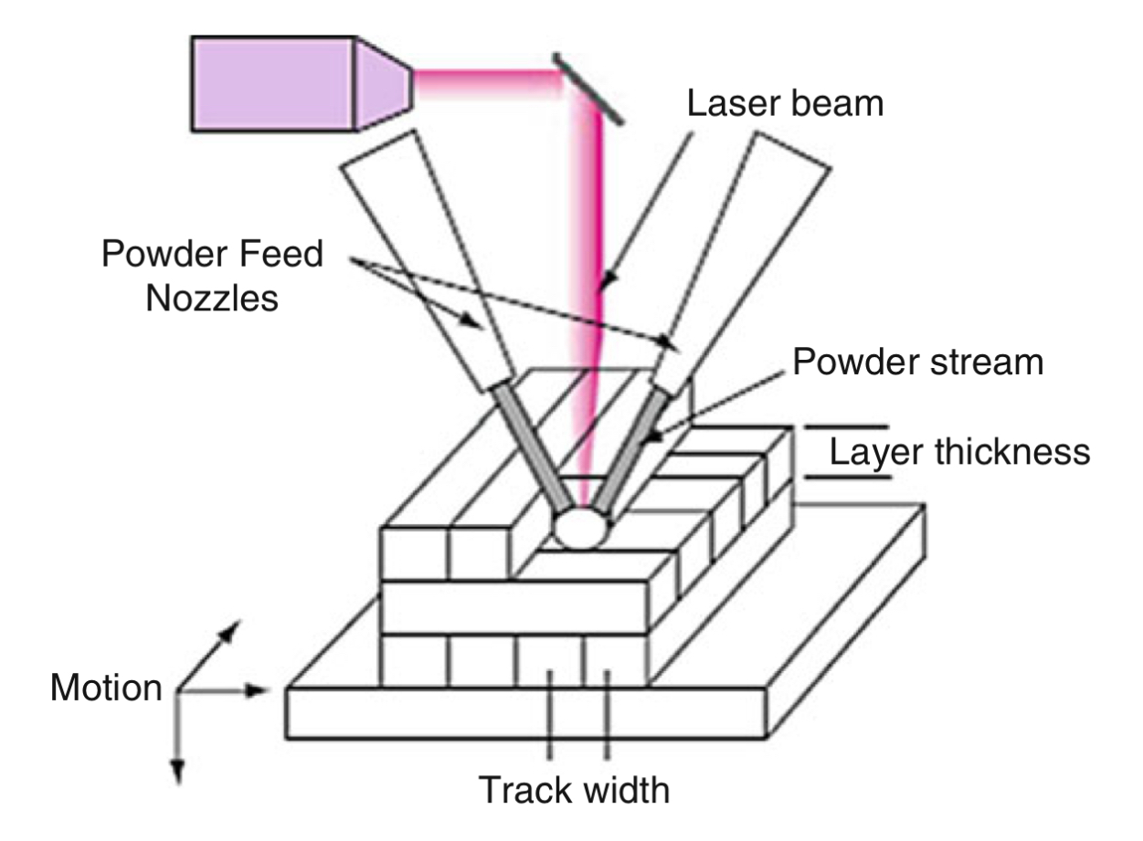

*Fig. 2: Laser-based powder DED [2]*

*“melt materials as they are being deposited [2]”* is the core principle of DED. Note that the energy density of the beam must be above a critical value to form a melt pool on the substrate.

**1.4 Thermogravimetric Analysis**

Thermogravimetric Analysis (TGA) is a technique in which the mass of a substance is monitored as a function of temperature and time as the sample specimen is subjected to a controlled temperature program in a controlled atmosphere [5].

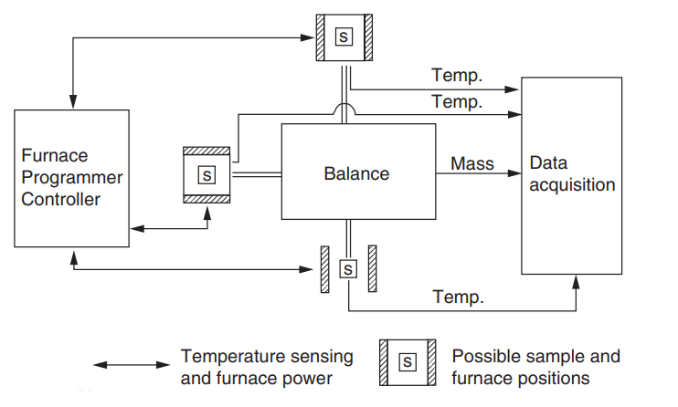

*Fig. 3: Working Principle of TGA [5]*

*Figure 3* illustrates the working principle of TGA. The heart of the thermogravimetric analyser is the “balance,” which can measure the sample mass as a function of temperature and time. Heating parameters are controlled using “Furnace programmer.” Computers are used for data acquisition.

**1.5 Bragg’s Law**

**Diffraction:** Diffraction is a scattering phenomenon which occurs whenever wave motion encounters a set of regularly spaced scattering objects, given that the wavelength of the wave motion is of the same order of magnitude as the repeat distance between the scattering centres [6]. *Figure 4* shows the diffraction phenomenon of X-rays by a crystal.

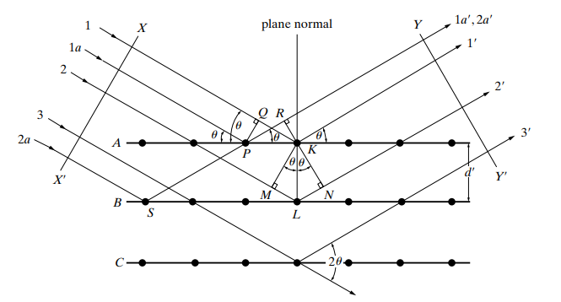

*Fig. 4: Diffraction of X-rays by a crystal [6]*

When an X-ray encounters an atom, it gets scattered in all directions. In figure 4, only those diffracted beams are shown whose exit angle is equal to the angle of incidence. In plane A, rays 1 and 1a are striking K and P atoms respectively. After striking, they get scattered in all directions but only are completely in phase and can reinforce each other. The path difference between is .

Therefore, the path difference between is zero. This implies that they are in same phase.

Similarly, considering ray 1 and ray 2, the path difference is . This is the additional distance travelled by ray 2.

*(where is the interplanar spacing)*

It is the constructive interference of scattering from the atoms which produces diffracted intensity. Constructive interference occurs when the path difference between the two waves is an integer multiple of the wavelength (𝜆).

Therefore,  *(where n = 1,2,3…)*

**1.6 X-Ray Diffraction**

XRD is a high-precision non-destructive technique that provides important information about the structural characteristics of the materials by enabling chemical composition identification [7].

Every crystalline substance gives a pattern; the same substance always gives the same pattern; and in a mixture of substances, each produces its pattern independently of the others – *Hull (1919).*

**Working Principle:**

From *Figure 5*, X-rays from the tube T are incident on a crystal C which may be set at any desired angle to the incident beam by rotation about an axis through O. D is a detector which measures the intensity of the diffracted X-rays.

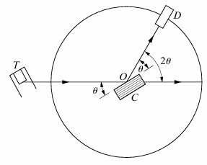

*Fig. 5: Schematic of XRD [6]*

**Scattering of an X-Ray by a single electron:**

[6].

*Where, is the distance from electron*

*is the scattering angle*

**Scattering of an X-Ray by an atom:**

When an x-ray beam encounters an atom, each electron in it scatters part of the radiation coherently in accordance with the Thomson equation [6].

is known as *“the atomic scattering factor.”* It is used to describe the efficiency of scattering of a given atom in a given direction.

**Structure Factor:**

Structure Factor is a mathematical expression used to describe how X-rays are scattered by the atoms in a crystal lattice. It provides critical information about the distribution of atoms within the crystal and is essential in determining the crystal’s atomic structure from X-ray diffraction data [6].

*where,* is the Structure Factor.

is the Atomic Scattering Factor of atom.

are the co-ordinates of the position of atom.

The intensity of the beam diffracted by all atoms of the unit cell in a direction predicted by Bragg’s law is proportional to

**Structure Factor for FCC unit cell:**

The FCC unit cell contains 4 atoms. These 4 atoms are positioned at the following fractional coordinates within the unit cell. They are:

- Corner Atom.

- Face-centered atom on the XY Plane.

- Face-centered atom on the XZ Plane.

- Face-centered atom on the YZ Plane.

Substituting these values in the previously stated Structure Factor equation yields:

From this equation, it can be stated that:

**Case 1:** *h + k + l is even* i.e. *h, k, l* are all even or all odd *(unmixed indices)*

**Case 2:** *h + k + l* is odd *(mixed indices)*

Therefore, reflections may occur for such planes as (111), (200), (220) et

Chapter 2

Literature Review

**2.1 XRD Peak Broadening**

Paterson [6] built upon the study conducted by Warren and Averbach [10], identifying three key factors contributing to the broadening of XRD peaks.

* Size Broadening
* Strain Broadening
* Instrument Broadening

**Size Broadening:**

The size broadening of an XRD peak is determined by *“Scherrer’s Equation.”* It states:

Where, - Average Crystallite Size.

- Incident radiation wavelength.

- peak broadening due to size

- Half of diffraction angle.

- Shape Factor ( = 0.9 for spherical particles)

**Strain Broadening:**

Differentiating Bragg’s law yields the relation between the strainand strain broadening [6].

The derivation for this equation is stated below.

In this case, strain is defined as

For a change in the interplanar spacing (), there is a corresponding change in the Bragg angle ().

Expanding *Sin (A + B) = SinACosB + CosASinB*

Assuming is small, and

(negative sign indicates direction of peak shift)

**Instrument Broadening:**

This refers to the additional broadening of diffraction peaks caused by imperfections and limitations of the instrument itself, rather than the sample.

Factors contributing to Instrument Broadening are:

* **Detector resolution**: Limited resolution of the detector used to measure the diffraction pattern can contribute to peak broadening.
* **Crystal imperfections in optics**: Imperfections in monochromators or focusing crystals within the X-ray instrument can distort the beam and broaden peaks.
* **Instrument vibrations**: Mechanical vibrations within the instrument can also cause broadening.
* **X-ray source size**: The finite size of the X-ray source can lead to divergence, which affects the resolution and broadens the peaks.

**2.2 Curve Fitting**

Curve fitting is a process of finding a mathematical function that best represents a set of data points.

Curve fitting of an X-ray diffractogram is crucial for accurate peak identification and quantitative analysis, allowing for precise localization of peaks and extraction of key data like intensity and area. It also reduces noise, enhancing the clarity of meaningful features in the data.

The Gaussian function is often the best choice for fitting an X-ray diffractogram [8] due to its ability to accurately represent the shape of diffraction peaks, which are typically symmetrical and bell-shaped. The bell-shape nature of the gaussian curve is illustrated in *Figure 6.*

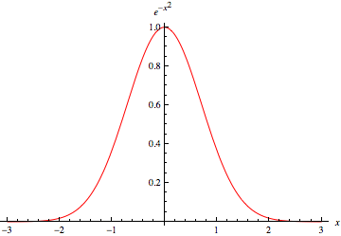

*Fig. 6: Bell Shape of Gaussian Function [13]*

Gaussian Function: [13]

*Where, – Peak Height (Amplitude).*

*– Standard deviation.*

*– Peak Position.*

Full Width Half Maximum (FWHM) occurs at

Substituting this and solving yields

**2.3 Relation between Strain and Crystallite Size**

Since Gaussian broadening combines quadratically, the relationship becomes additive in terms of their squares. This means that the overall broadening effect can be expressed as the sum of the squares of the individual contributions.

Where,

*c =*

Therefore, Strain and Crystallite size can be calculated from slope and intercept respectively.

**2.4 Dislocation Density**

[110] is the closest packed direction in FCC Crystal structure.

Chapter 3

Experimental Procedure

**Sample Preparation:** 1300W_DED_316L steel samples were cut using an Electric Discharge Machine (EDM).

**TGA:** To assess the thermal stability and potential weight loss of the samples at elevated temperatures, TGA was conducted. This step provided an insight into the thermal degradation properties of the material.

**XRD:** XRD measurements were performed on the samples to analyse their crystallographic structure. The samples were heated to 400°C, 600°C, 800°C, 1000°C, and 1150°C, and after reaching each temperature, XRD readings were recorded. An initial reading was taken at 25°C for all samples before heating.

**Plotting:** All plots were generated using Origin software. [14]

**Inverted Microscope** and **Vickers Hardness Tester** were used to obtain microstructures and hardness values respectively.

**XRD Parameters**

**Incident radiation wavelength –**  = 1.5406 Å

**Scan Mode –** Continuous

**Scan Rate –** 300 scans per minute

**Sensitivity in measurement –**  =

**X-ray Tube parameters –**

**Cathode –** Tungsten; **Anode –** Copper; **Voltage –** 45kV; **Current –** 30mA

**Sample Stage –** Platinum heat strip (direct heating)

**Thermocouple –** Pt 10% RhPt

Chapter 4

Results

**4.1 TGA**

Thermogravimetric Analysis (TGA) was conducted prior to high-temperature X-ray Diffraction (XRD) to assess any potential mass loss or melting of the sample. As shown in *Figure 7*, the TGA thermal curve displayed an initial dip, attributed to the removal of porosity [2] within the material, followed by a stable ascend. The absence of significant weight loss throughout the analysis confirmed that no mass loss occurred, indicating the sample's readiness for subsequent high-temperature XRD measurements.

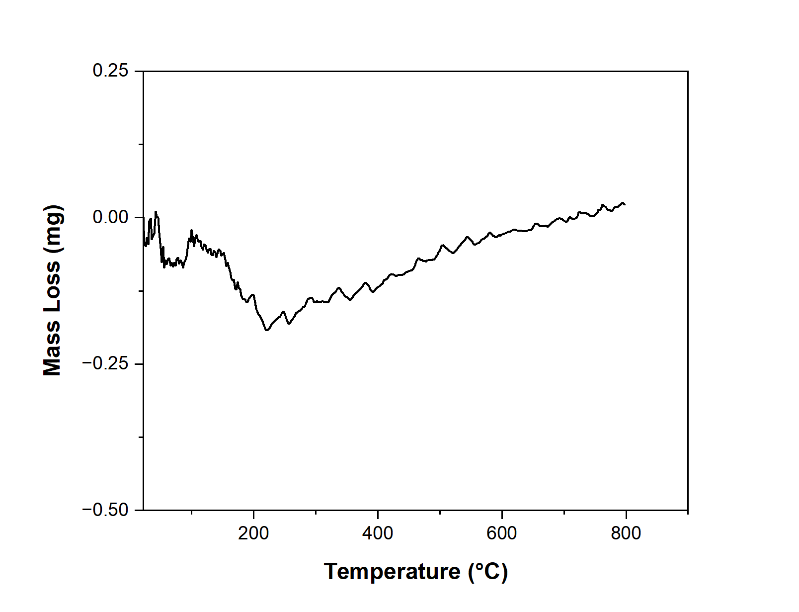

*Fig. 7: TGA of DED 316L*

**4.2 Determining Crystal Structure from X-Ray Diffractogram**

*Figure 8* shows the X-ray diffractogram of DED 316L steel at 25°C. The peak positions were determined using Gaussian curve fitting, with the results summarized in *Figure 8*. The interplanar spacing *(d)* values were calculated using Bragg’s law, as explained in *Section 1.5.* ratios are calculated for all 3 peaks and are rationalised to convert them into whole numbers. The values are listed in *Table 2.*

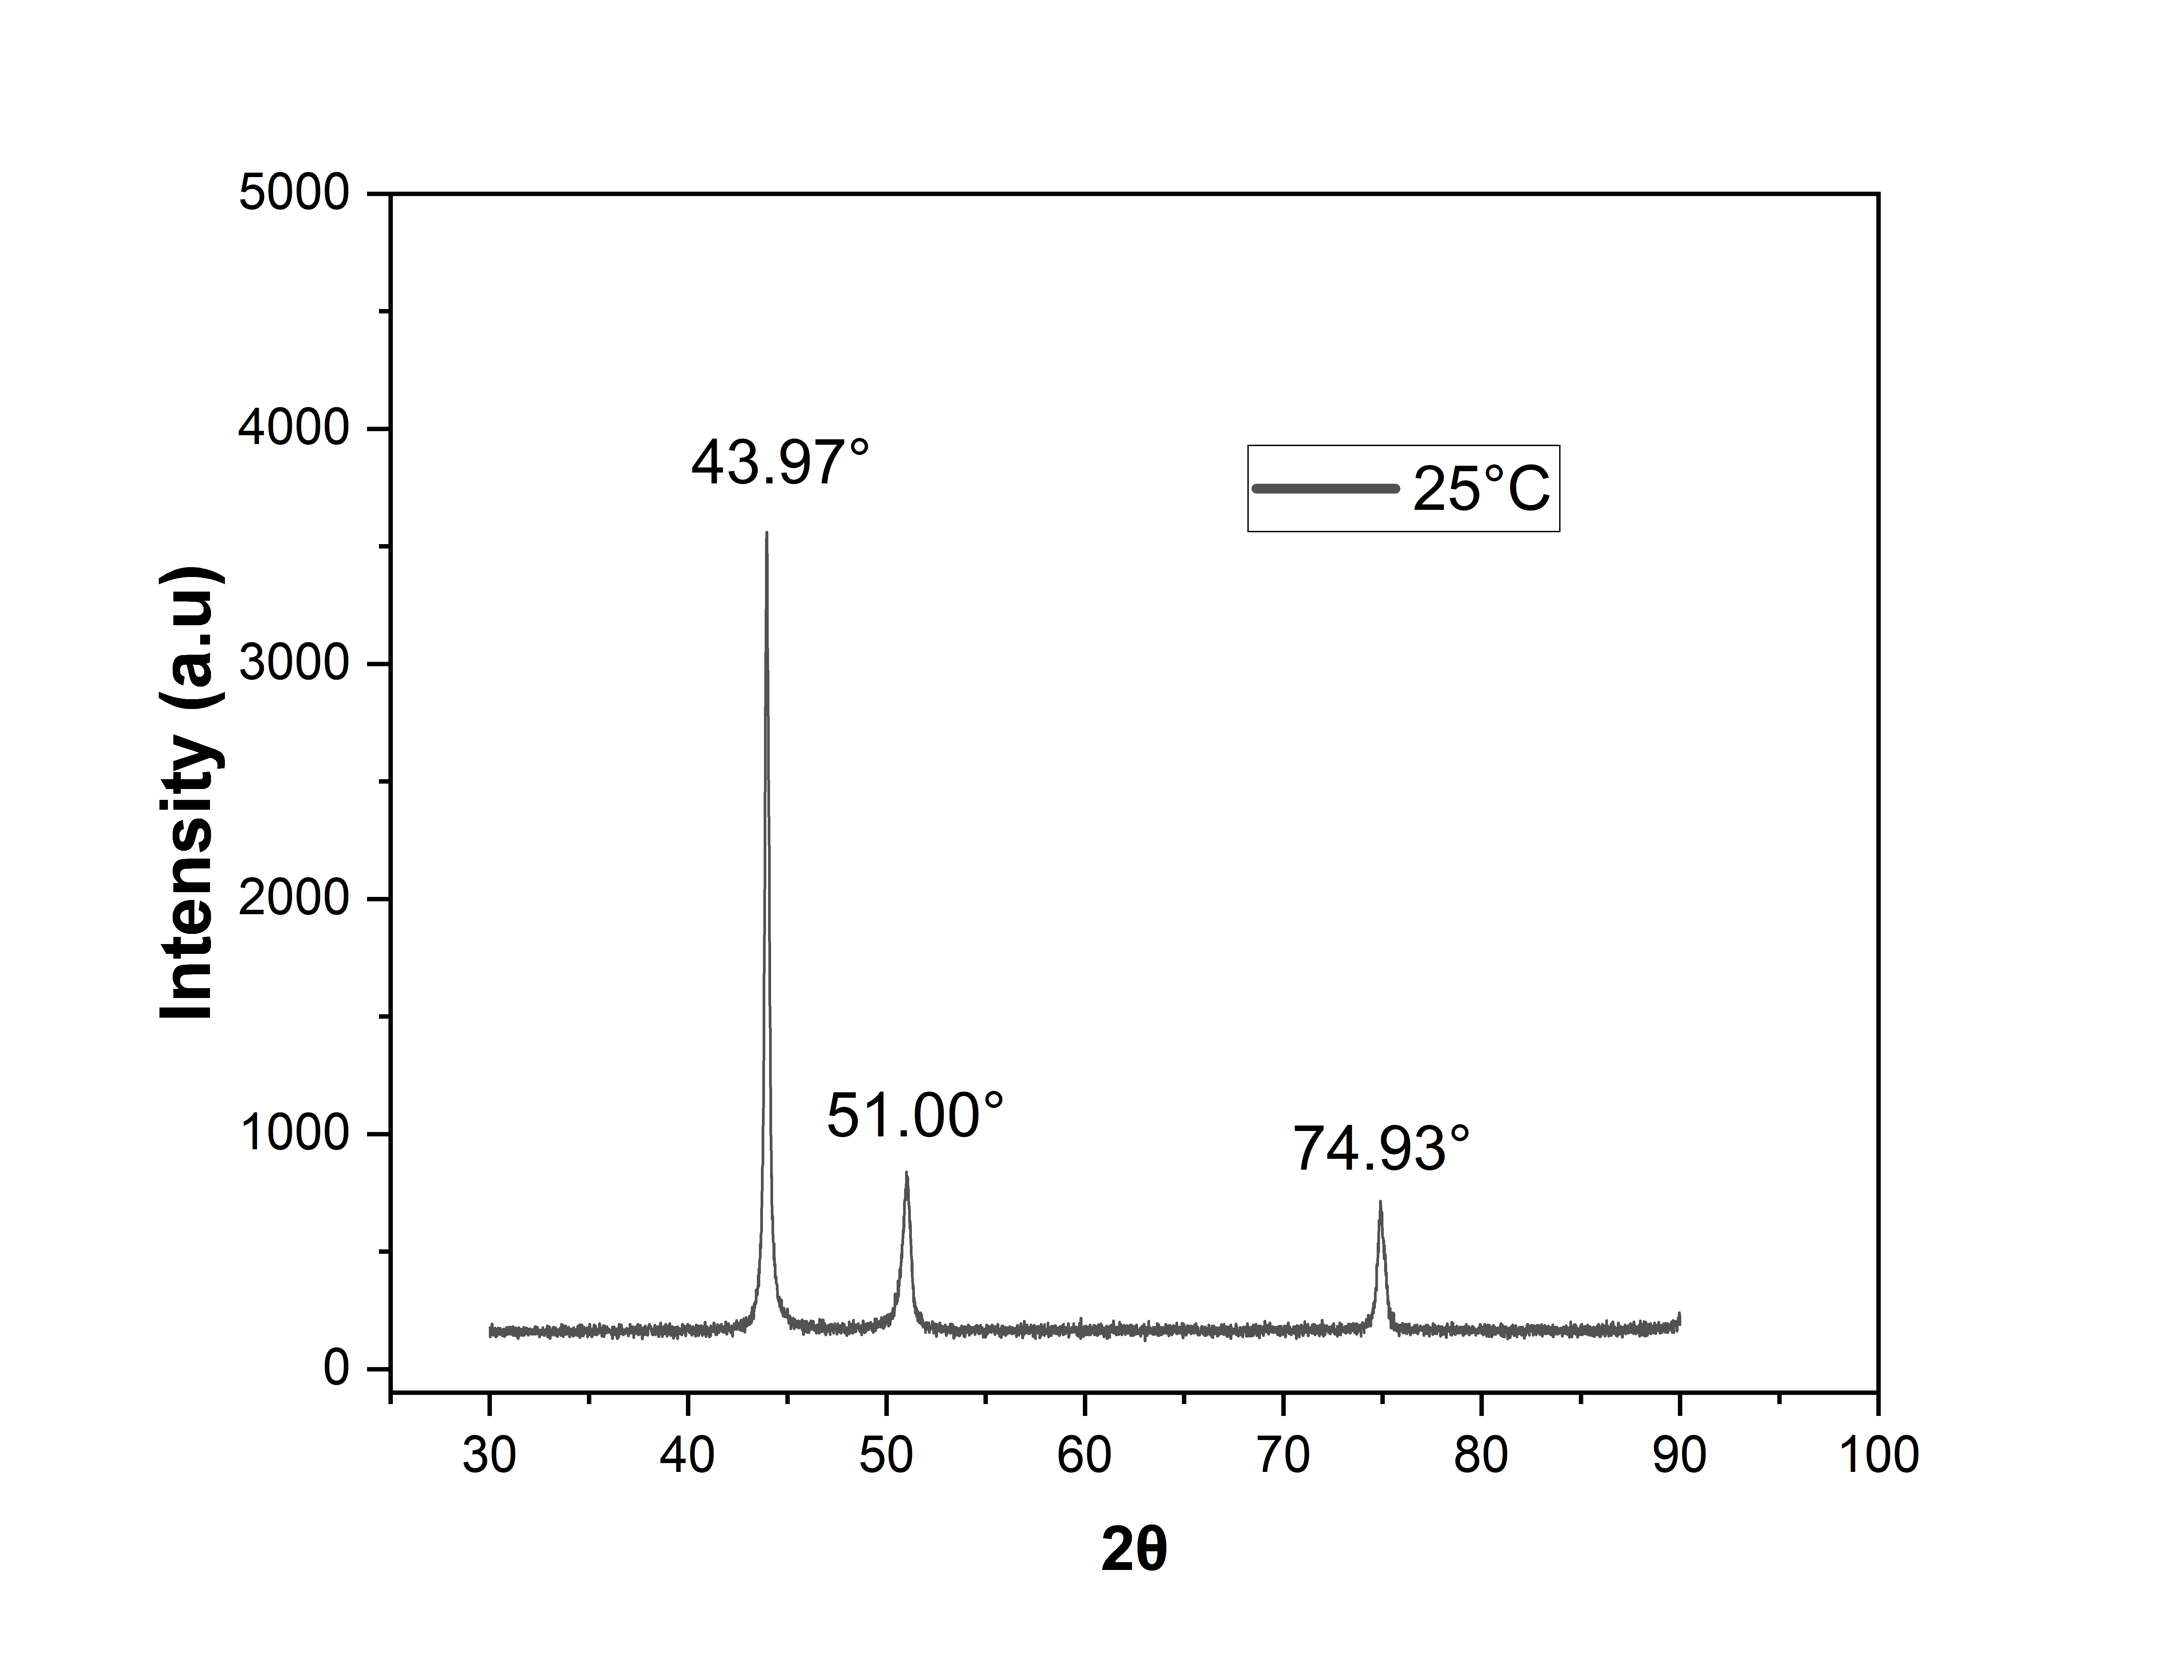

**(Degrees)**

*Fig. 8: XRD of DED 316L at 25°C*

|  |  |  |  |  |  |
| --- | --- | --- | --- | --- | --- |
| **Peak No.** | **d-Spacing (Å)** | **1/d2** | **Ratio** | **Ratio * 2** | **Ratio * 3** |
| 1 | 2.06 | 0.24 | 1.00 *(Peak 1 / Peak 1)* | 2.00 | 3.00 |
| 2 | 1.79 | 0.31 | 1.32 *(Peak 2 / Peak 1)* | 2.64 | 3.98 |
| 3 | 1.27 | 0.64 | 2.67 *(Peak 3 / Peak 1)* | 5.34 | 8.01 |

*Table 2: Interplanar spacing ratios of DED 316L at 25°C*

For an FCC Crystal Structure, the theoretical ratio of the lattice planes *(h k l)* follows the sequence:

1st Peak (1 1 1) –

2nd Peak (2 0 0) –

3rd Peak (2 2 0) –

From theory, the ratio of first 3 peaks of FCC is 3 : 4 : 8.

From *Table 2*, the ratio of final values is 3 : 3.98 : 8.01.

Therefore, experimental ratio is approximately equal to the theoretical ratio. This implies that the crystal structure of 316L steel is FCC.

**4.3 X-Ray Diffractograms at Elevated Temperatures**

**XRD at 400°C**

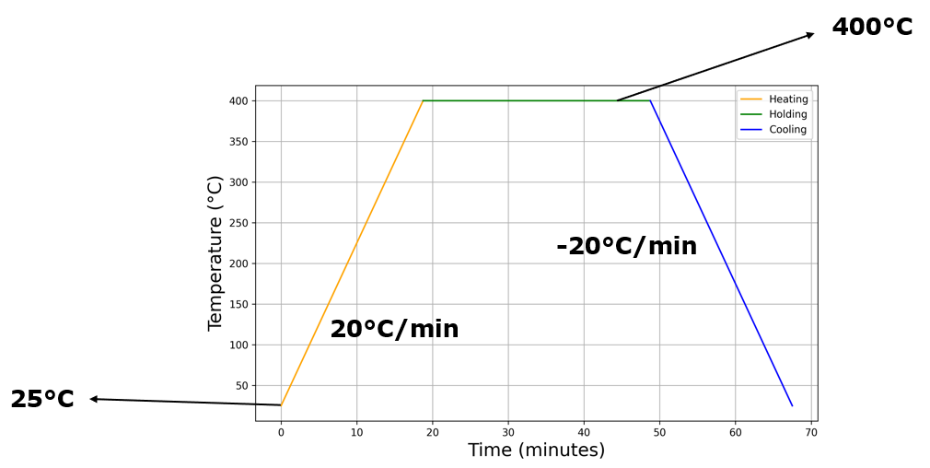

*Fig. 9: Heating Cycle at 400°C*

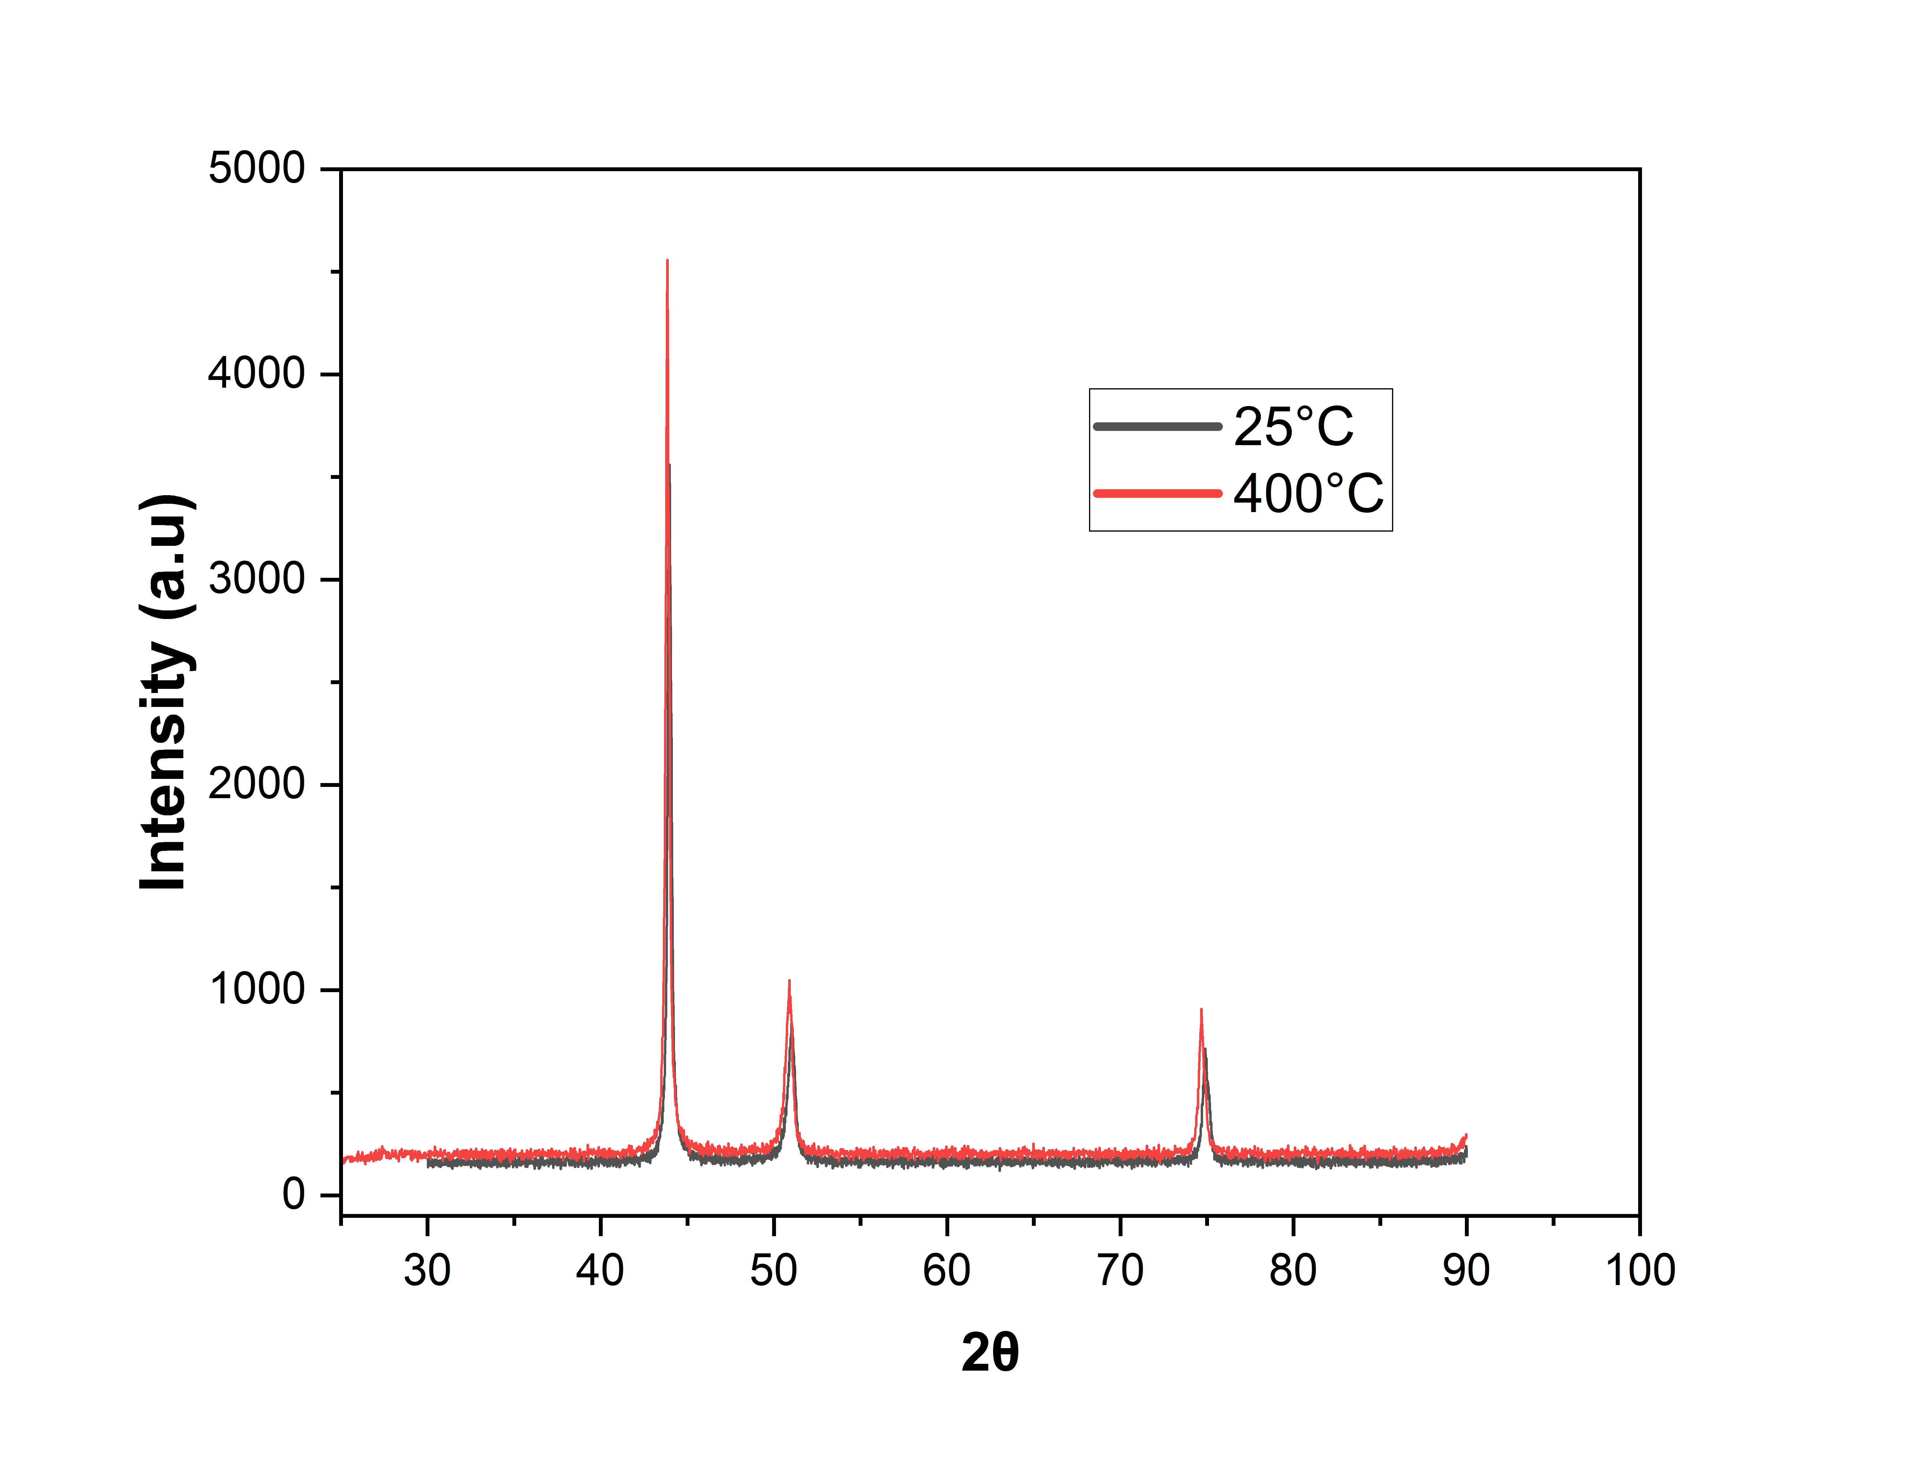

**(Degrees)**

*Fig. 10: XRD at 400°C*

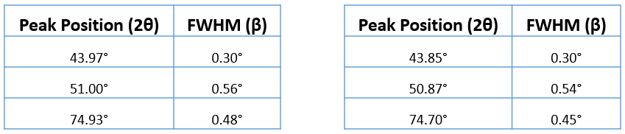

At 25°C At 400°C

*Table 3: Peak Position and FWHM at 400°C*

**XRD at 600°C**

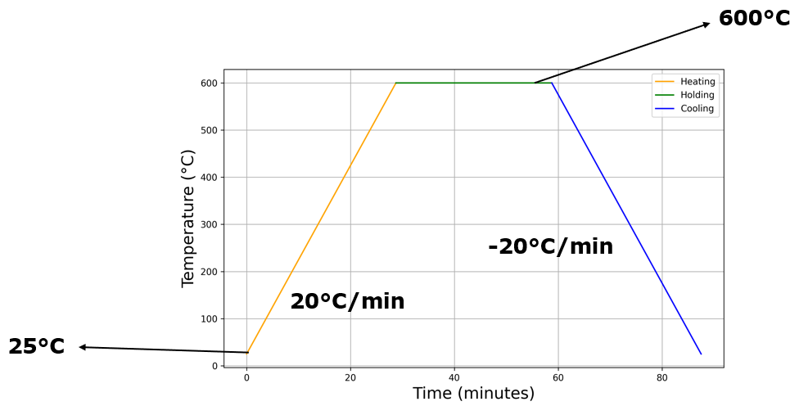

*Fig. 11: Heating Cycle at 600°C*

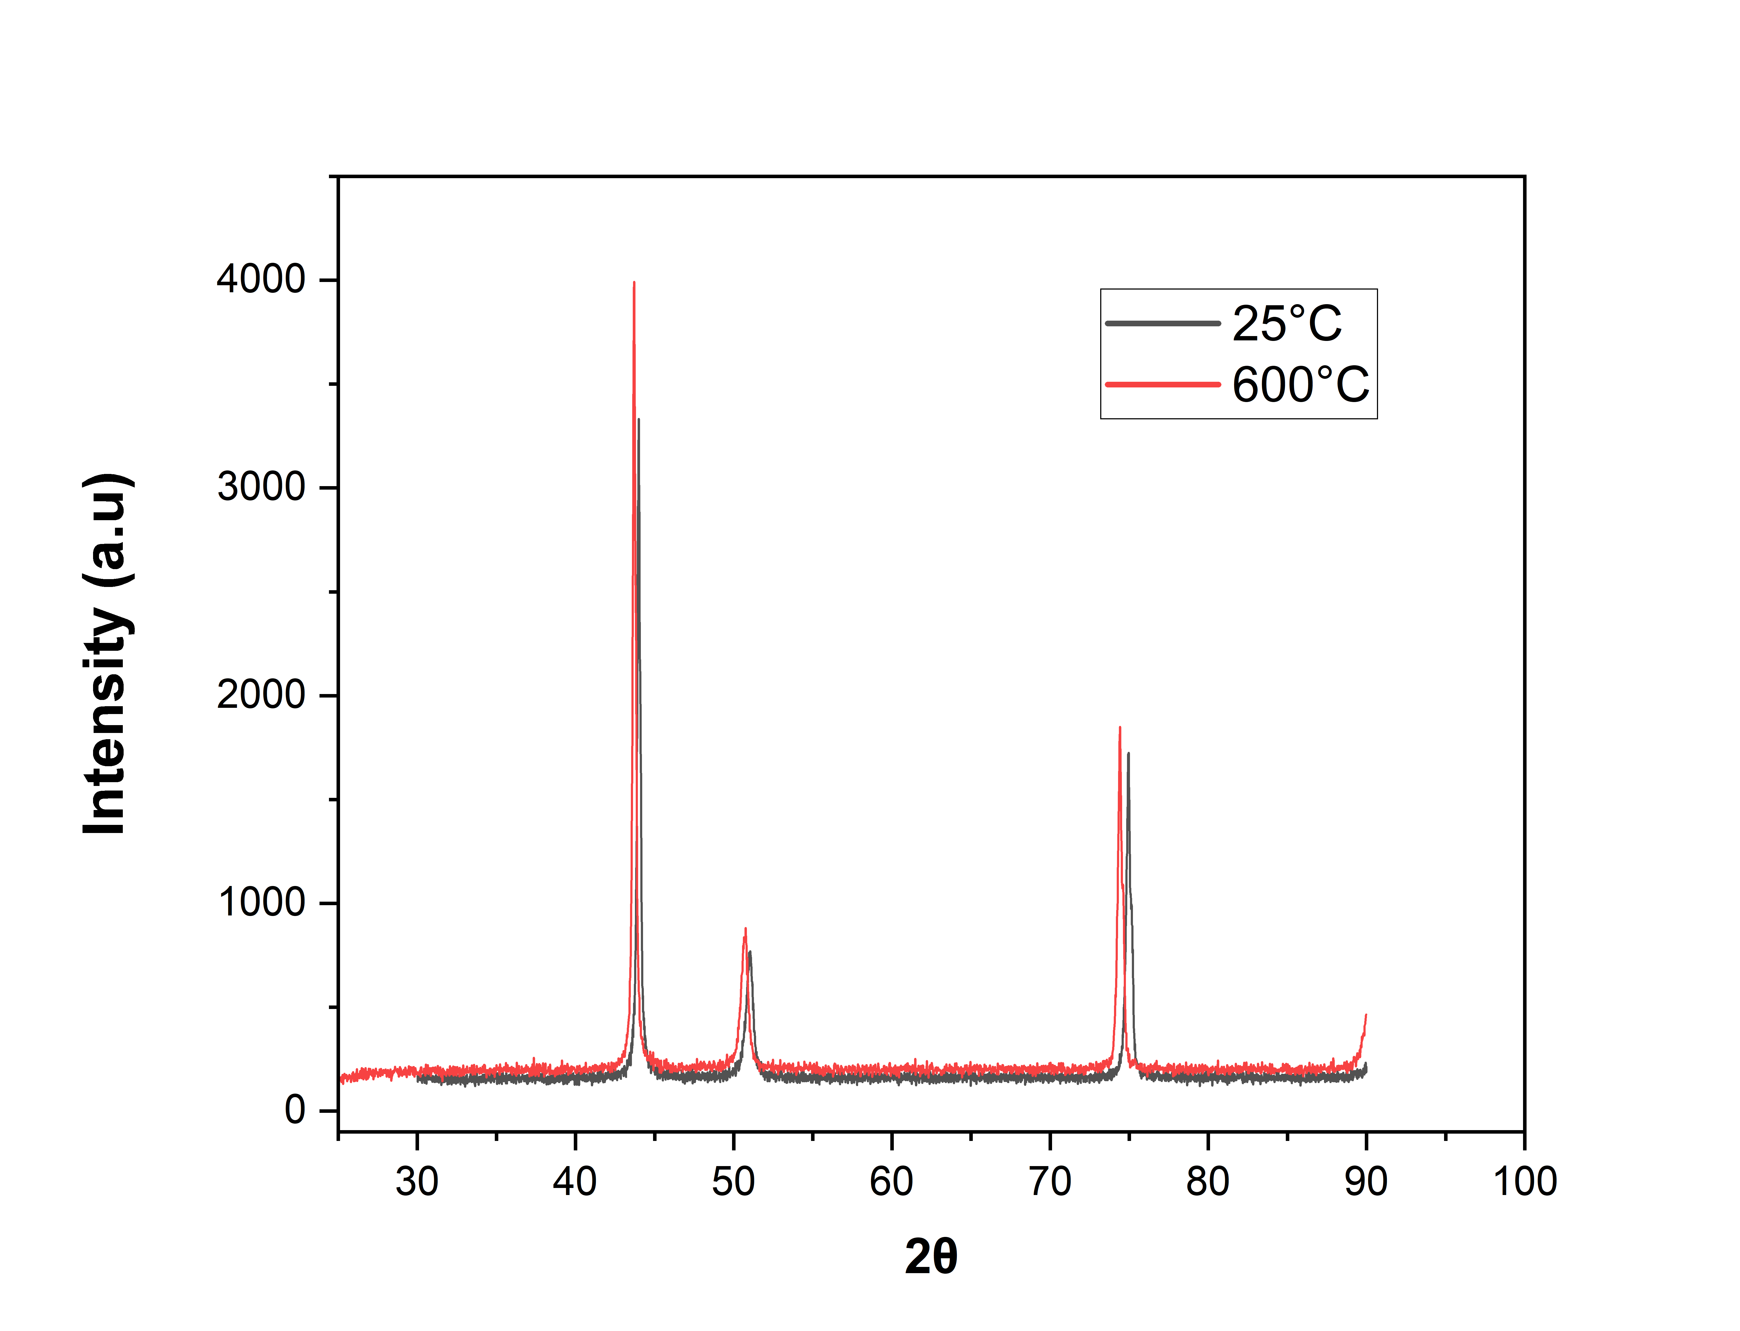

**(Degrees)**

*Fig. 12: XRD at 600°C*

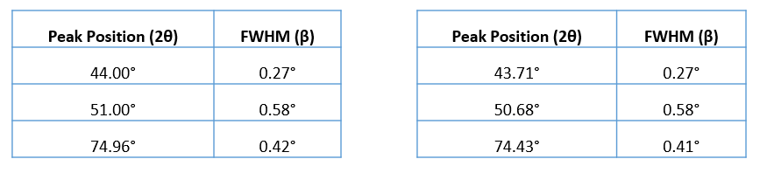

At 25°C At 600°C

*Table 4: Peak Position and FWHM at 600°C*

**XRD at 800°C**

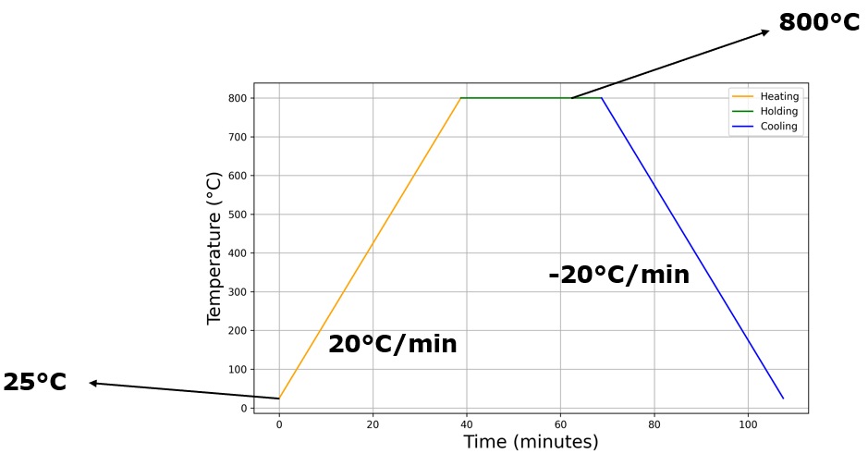

*Fig. 13: Heating Cycle at 800°C*

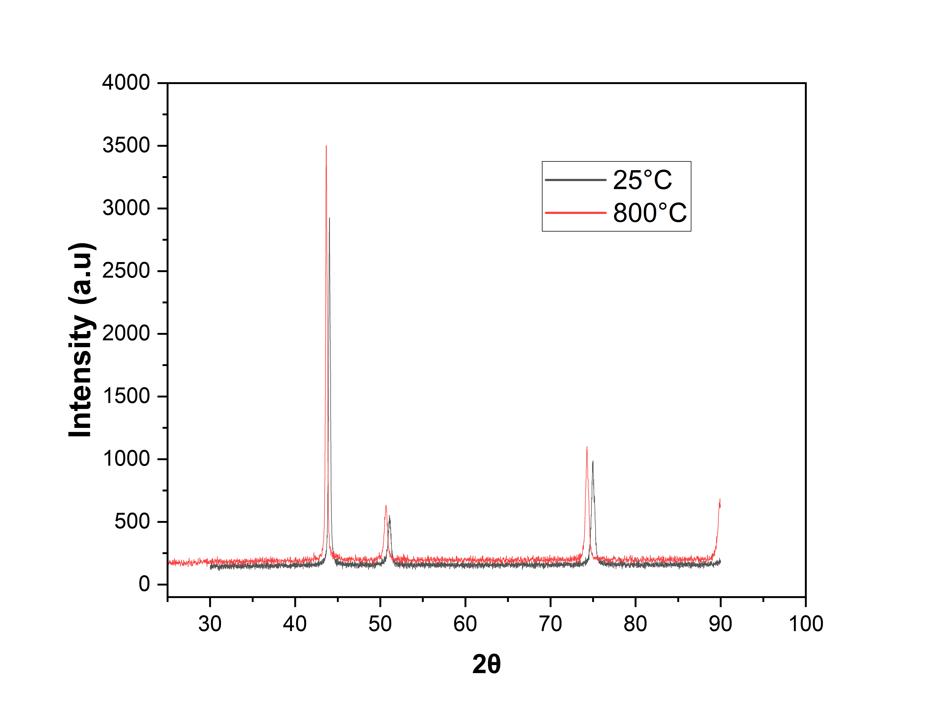

**(Degrees)**

*Fig. 14: XRD at 800°C*

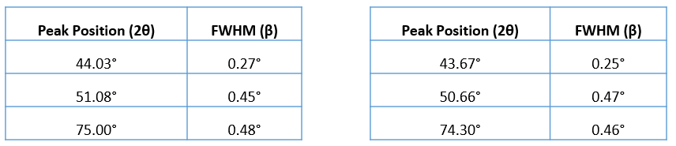

At 25°C At 800°C

*Table 5: Peak Position and FWHM at 800°C*

**XRD at 1000°C**

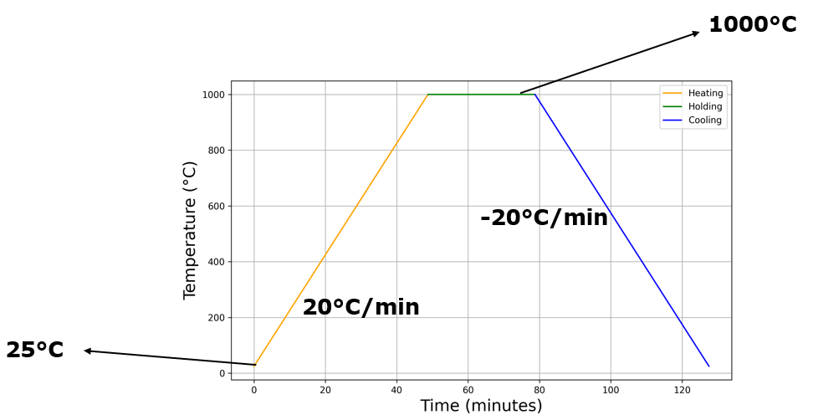

*Fig. 15: Heating Cycle at 1000°C*

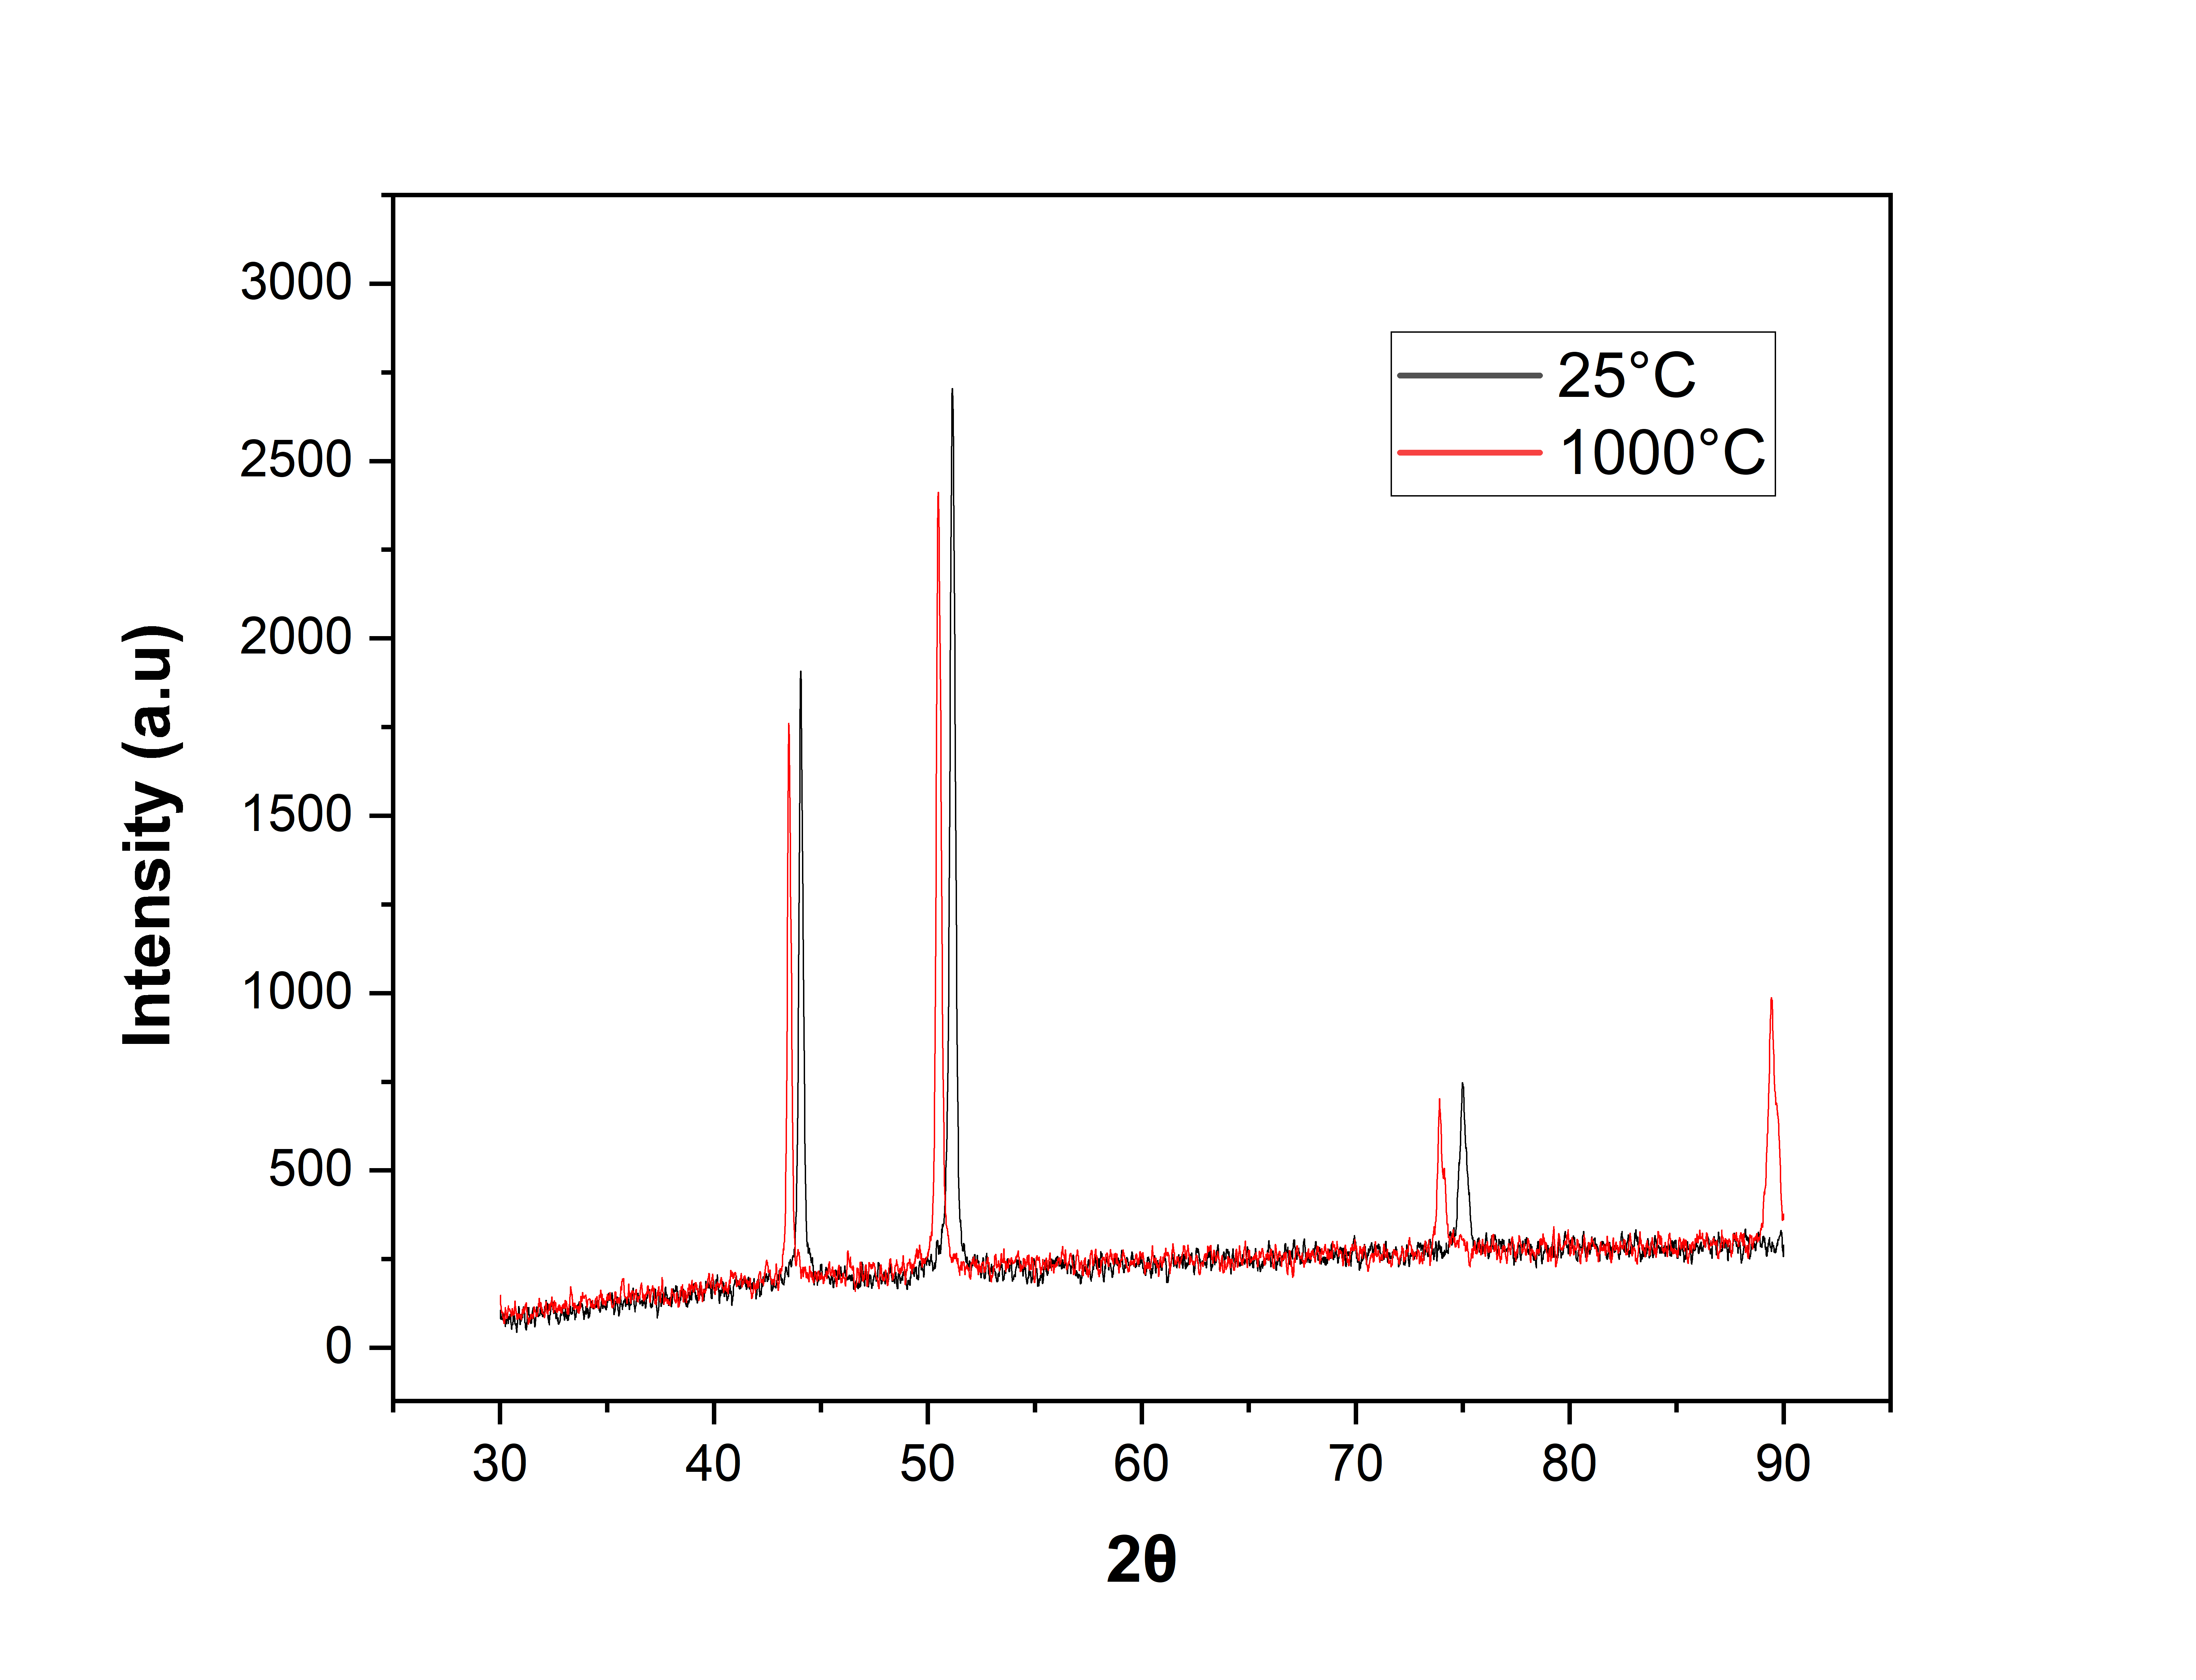

**(Degrees)**

*Fig. 16: XRD at 1000°C*

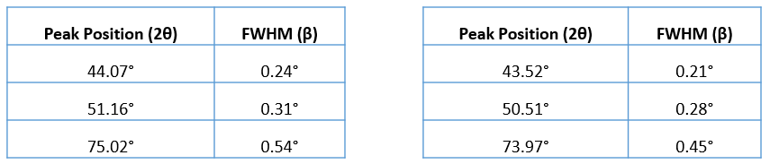

At 25°C At 1000°C

*Table 6: Peak Position and FWHM at 1000°C*

**XRD at 1150°C**

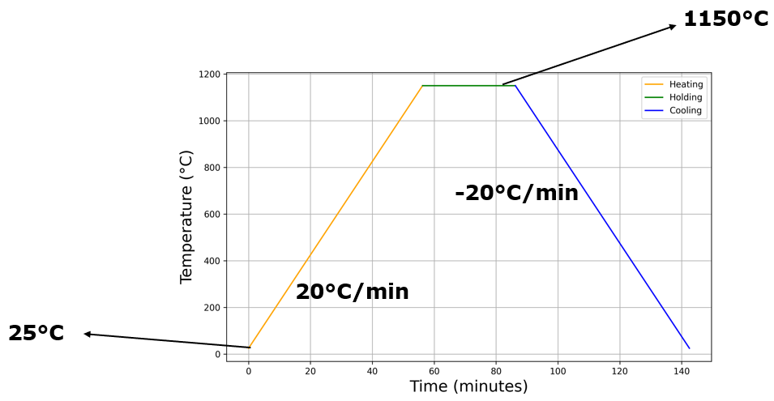

*Fig. 17: Heating Cycle at 1150°C*

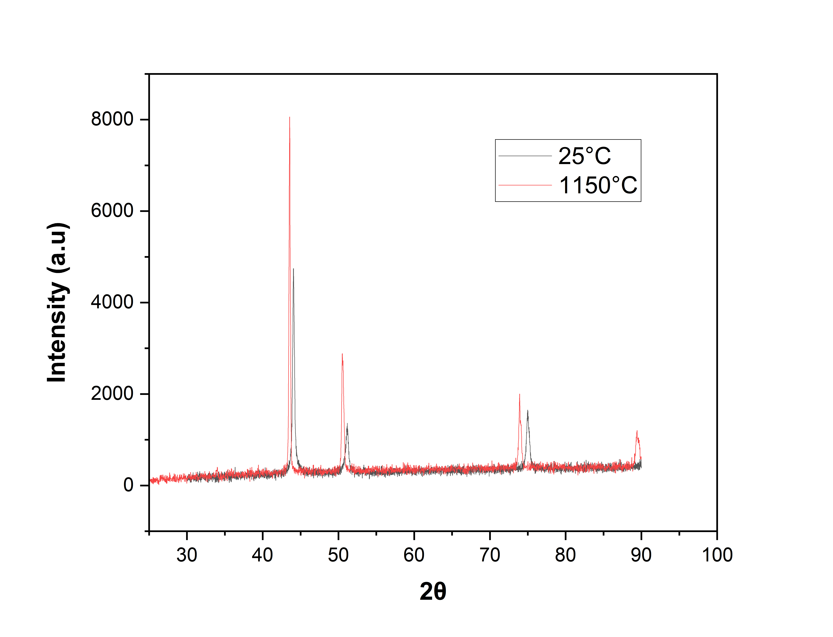

**(Degrees)**

*Fig. 18: XRD at 1150°C*

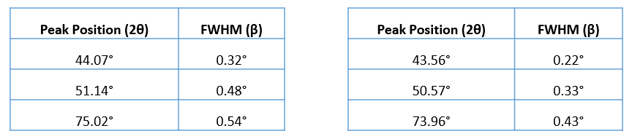

At 25°C At 1150°C

*Table 7: Peak Position and FWHM at 1150°C*

**4.4 Dislocation Density Calculations**

plots are demonstrated at different temperatures with their corresponding plot at room temperature. Using the equation derived in *Section 2.3* and *Section 2.4,* Crystallite Size, Strain and Dislocation Densities are calculated using the Peak Positions and FWHM values mentioned in *Section 4.3.*

*where K = 16.1 and b =*

* **400°C**

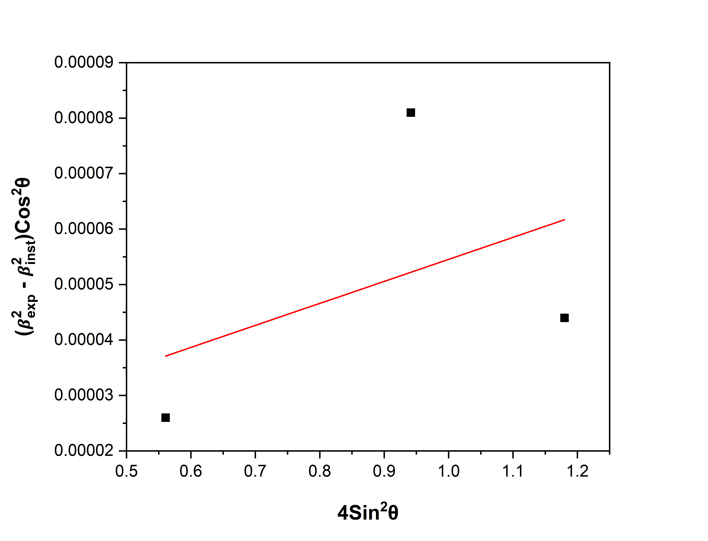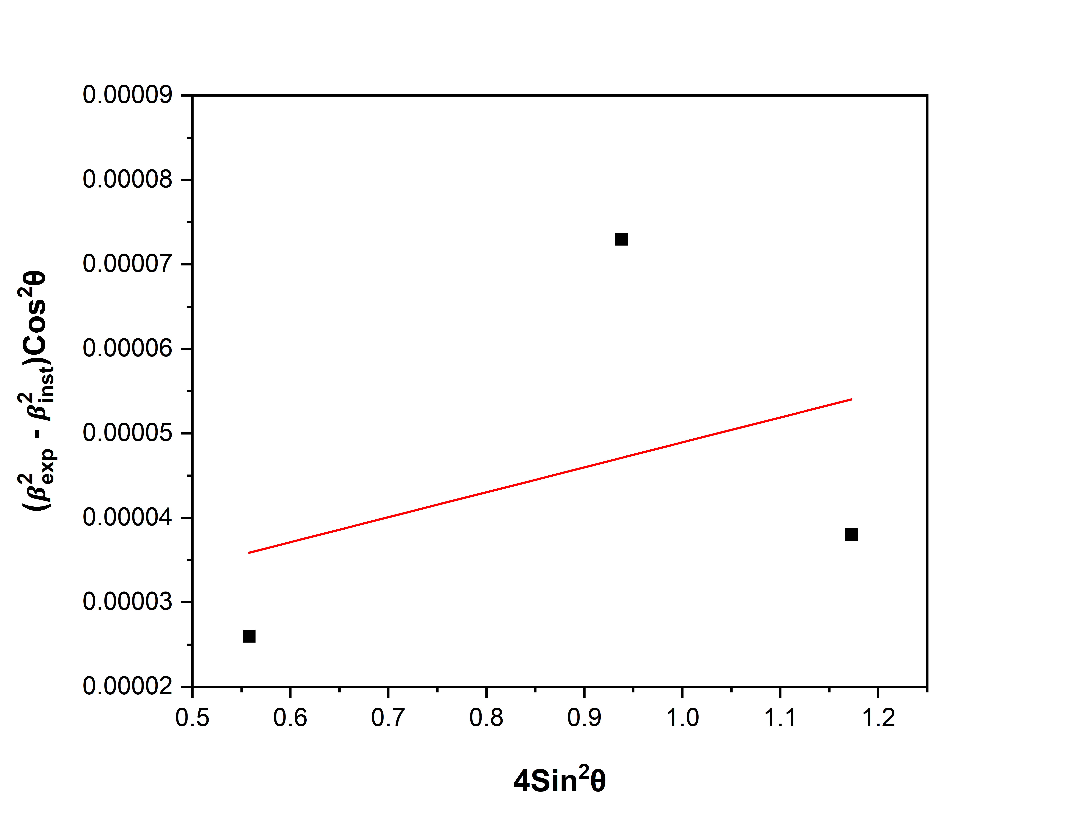

1. *(b)*

*Fig. 19: Strain plots (a) At 25°C (b) At 400°C*

|  |  |  |  |
| --- | --- | --- | --- |
|  | **Crystallite Size (nm)** | **Strain** | **Dislocation Density (m-2)** |
| **25°C** | 36.0 |  |  |
| **400°C** | 31.5 |  |  |

*Table 8: Crystallite Size and Dislocation Density at 400°C*

* **600°C**

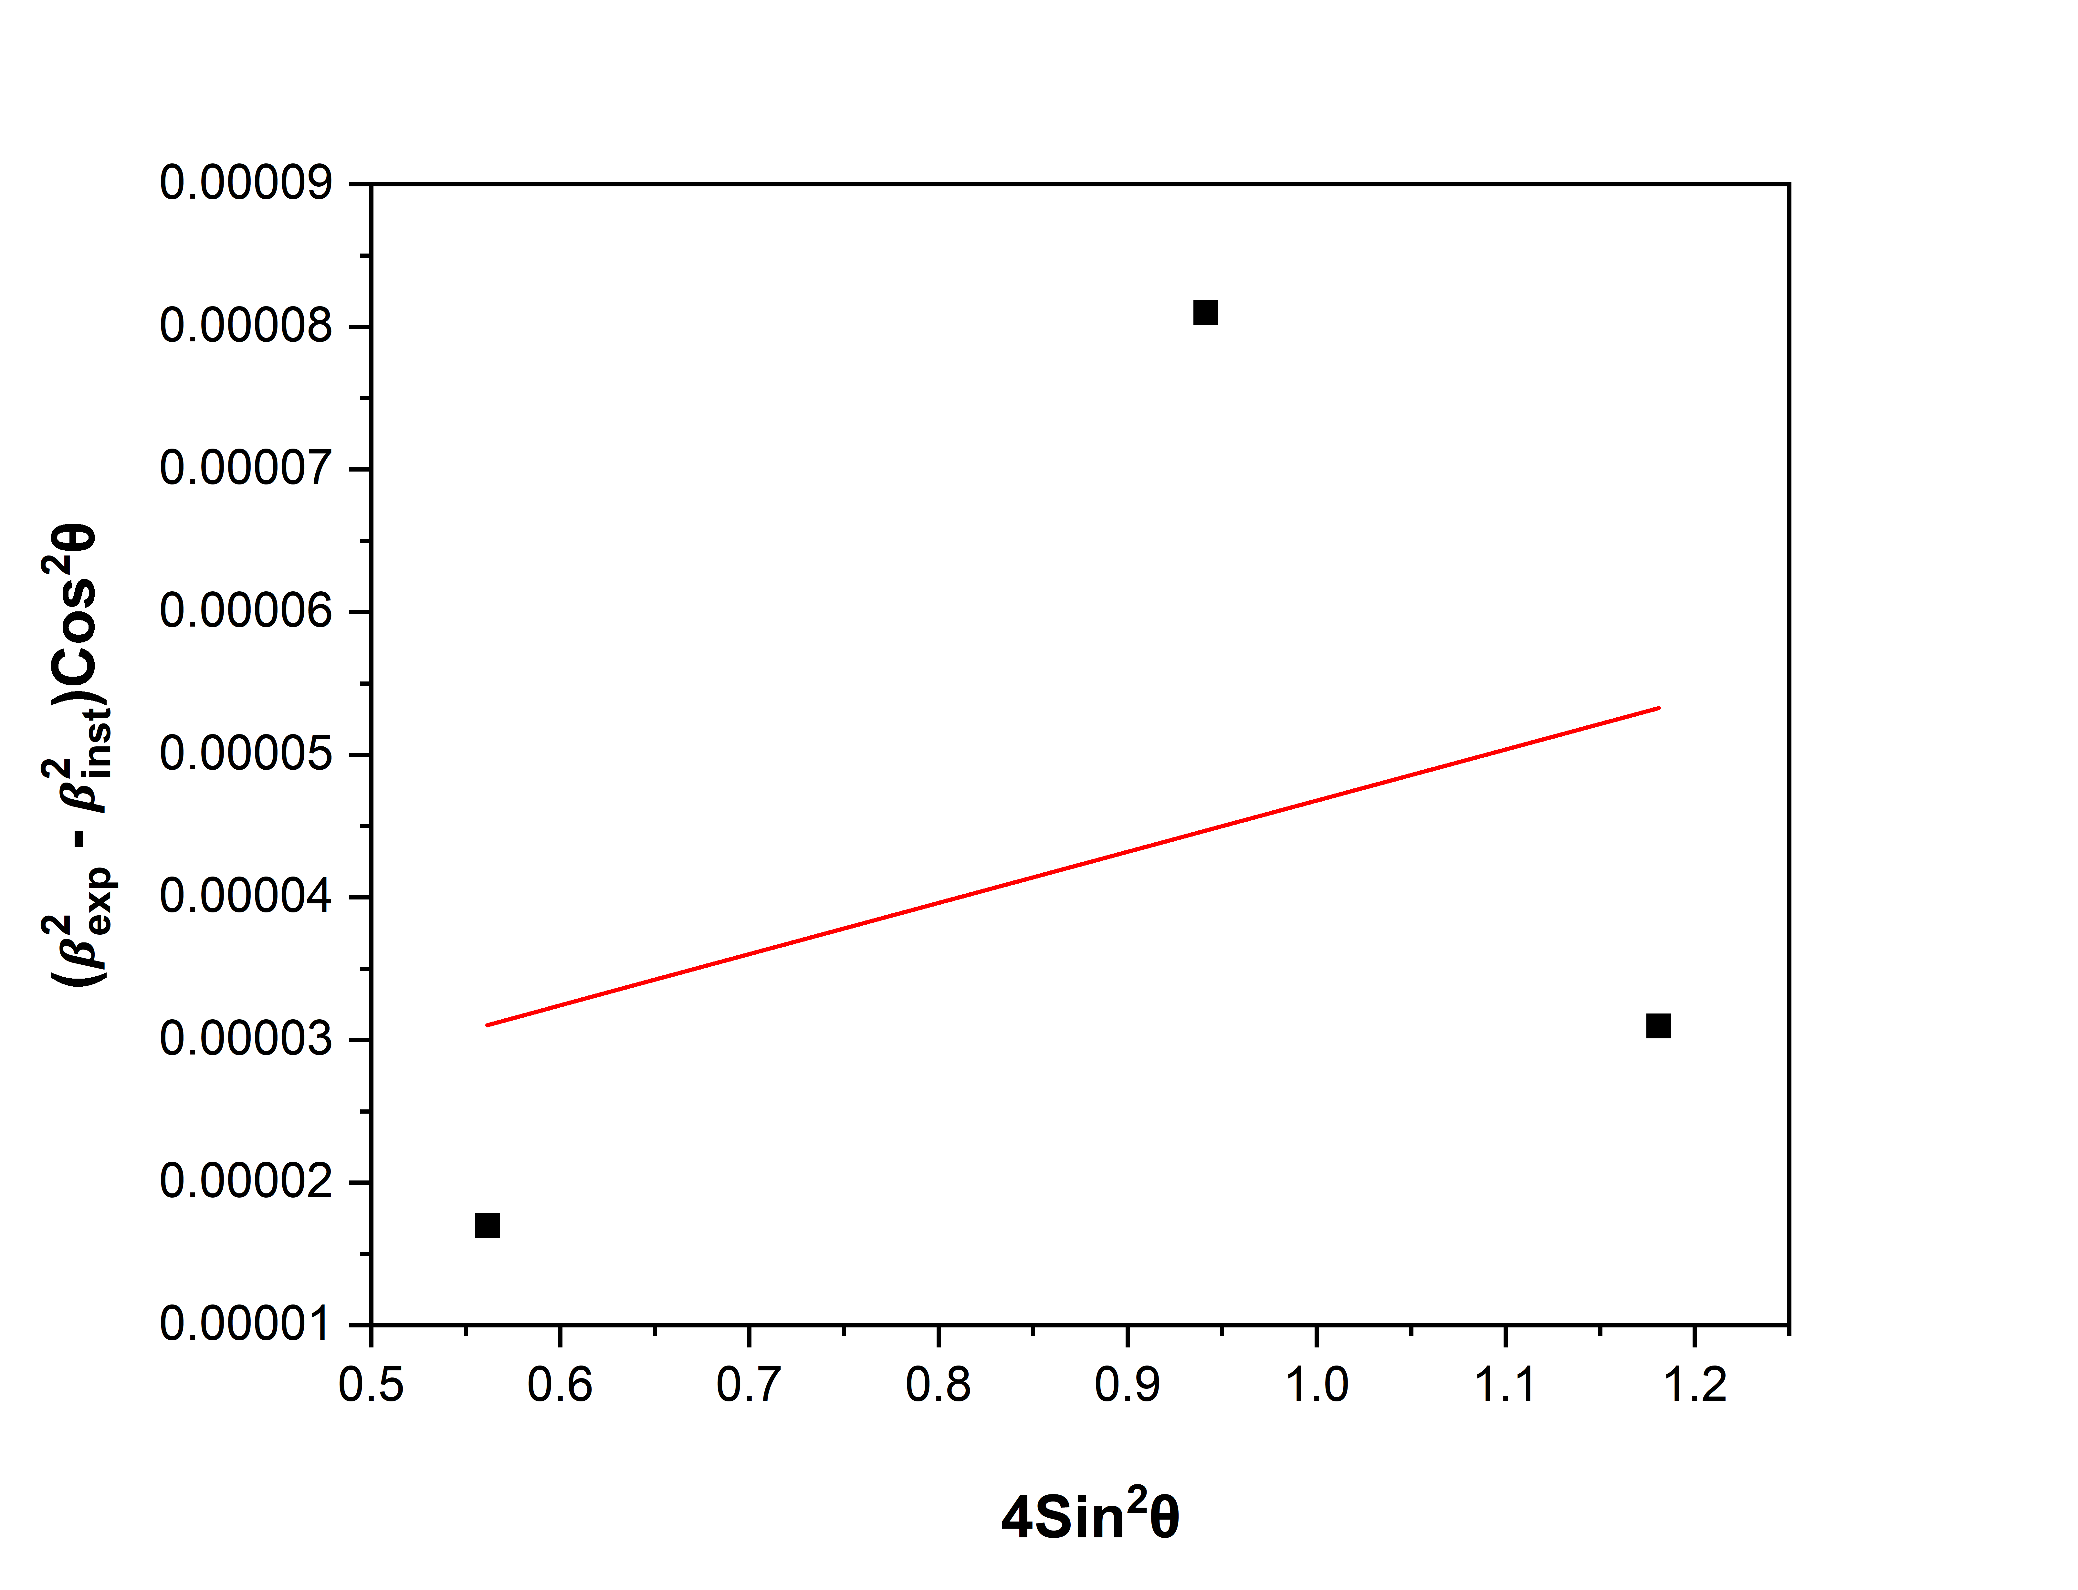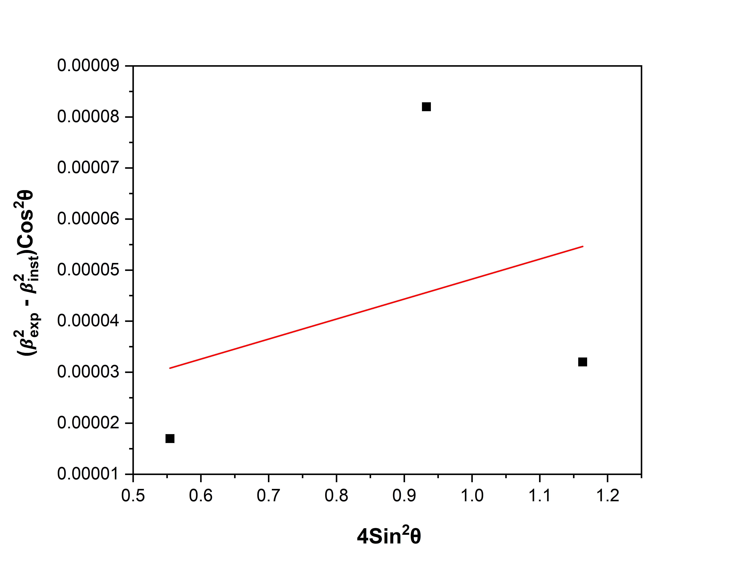

1. *(b)*

*Fig. 20: Strain plots (a) At 25°C (b) At 600°C*

|  |  |  |  |
| --- | --- | --- | --- |
|  | **Crystallite Size (nm)** | **Strain** | **Dislocation Density (m-2)** |
| **25°C** | 42.0 |  |  |
| **600°C** | 30.9 |  |  |

*Table 9: Crystallite Size and Dislocation Density at 600°C*

* **800°C**

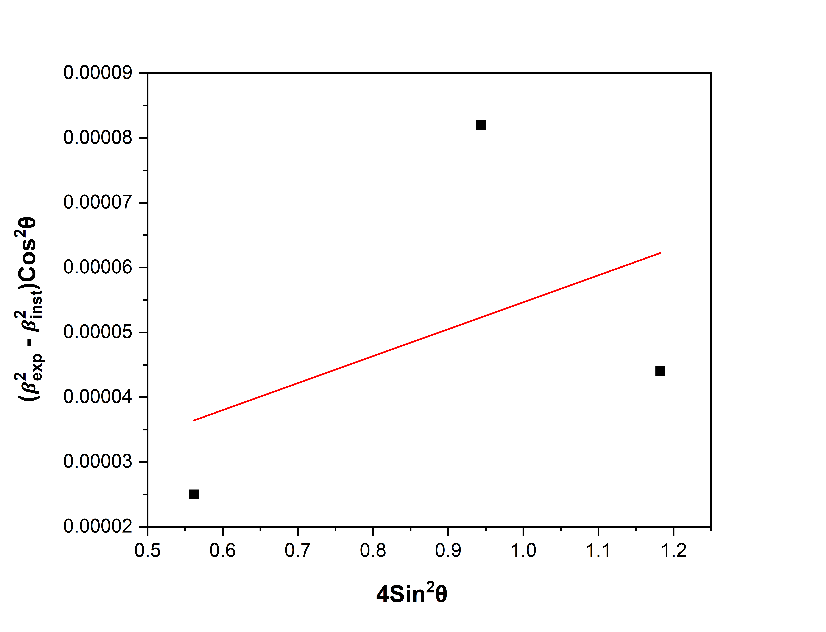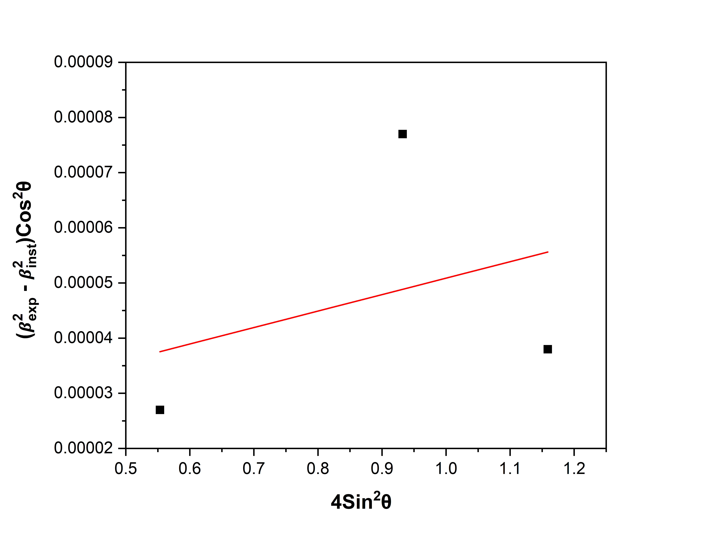

1. *(b)*

*Fig. 21: Strain plots (a) At 25°C (b) At 800°C*

|  |  |  |  |
| --- | --- | --- | --- |
|  | **Crystallite Size (nm)** | **Strain** | **Dislocation Density (m-2)** |
| **25°C** | 38.4 |  |  |
| **800°C** | 30.2 |  |  |

*Table 10: Crystallite Size and Dislocation Density at 800°C*

* **1000°C**



1. *(b)*

*Fig. 22: Strain plots (a) At 25°C (b) At 1000°C*

|  |  |  |  |
| --- | --- | --- | --- |
|  | **Crystallite Size (nm)** | **Strain** | **Dislocation Density (m-2)** |
| **25°C** | 37.0 |  |  |
| **1000°C** | 31.1 |  |  |

*Table 11: Crystallite Size and Dislocation Density at 1000°C*

* **1150°C**

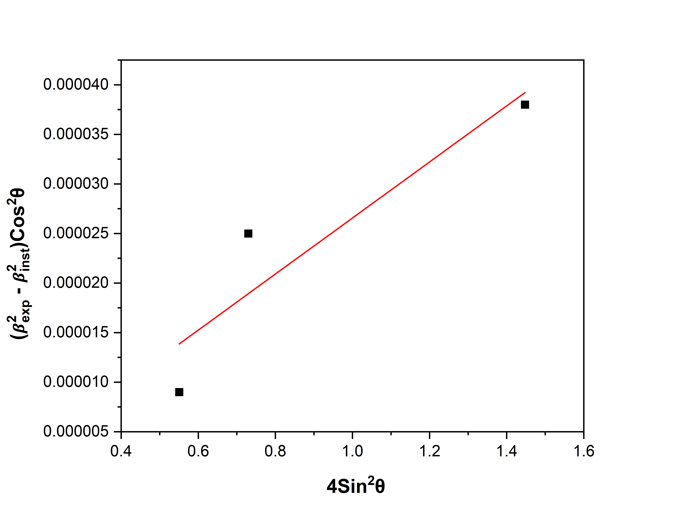

1. *(b)*

*Fig. 23: Strain plots (a) At 25°C (b) At 1150°C*

|  |  |  |  |
| --- | --- | --- | --- |
|  | **Crystallite Size (nm)** | **Strain** | **Dislocation Density (m-2)** |
| **25°C** | 41.4 |  |  |
| **1150°C** | 40.9 |  |  |

*Table 12: Crystallite Size and Dislocation Density at 1150°C*

**4.5 Microstructures**

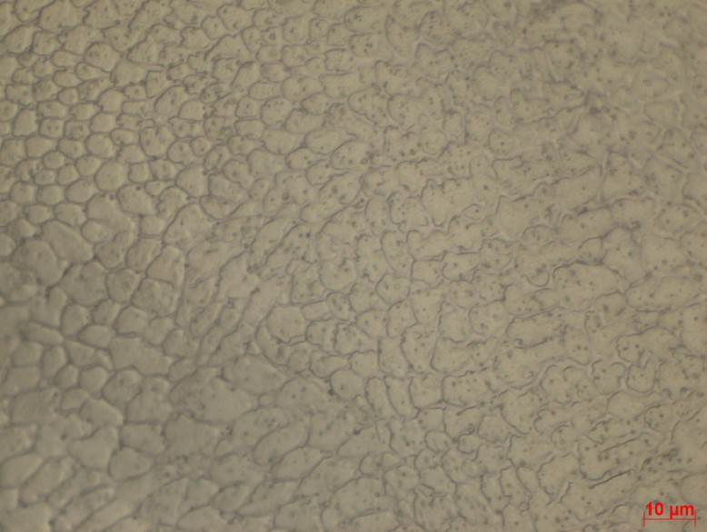 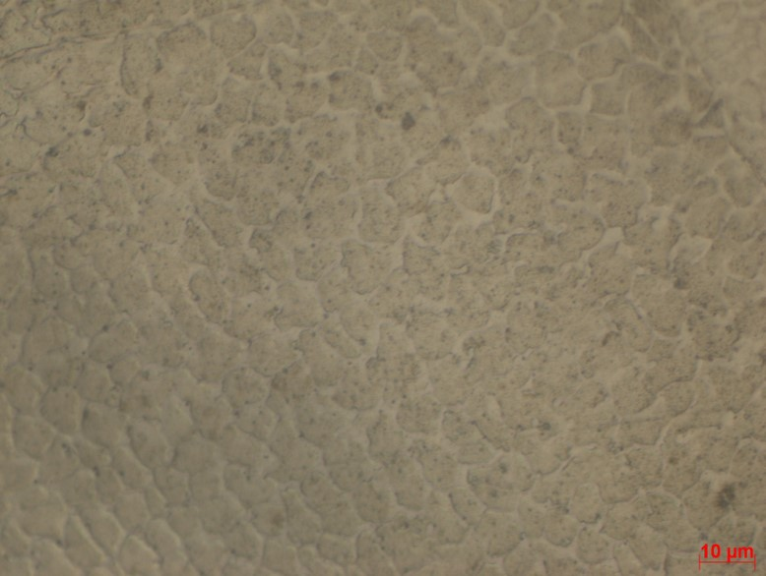

*(a) (b)*

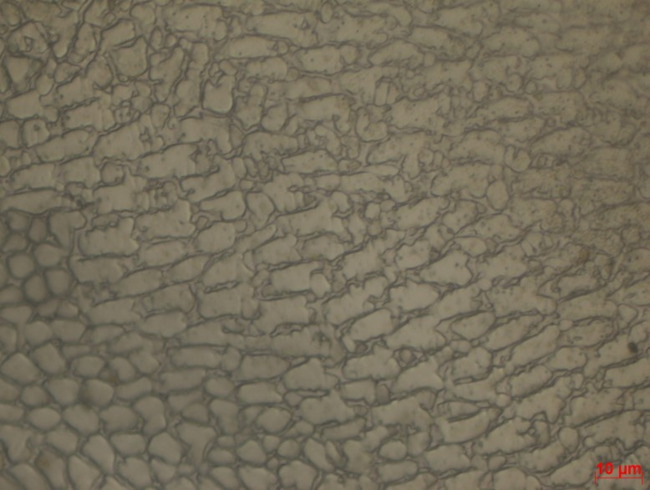 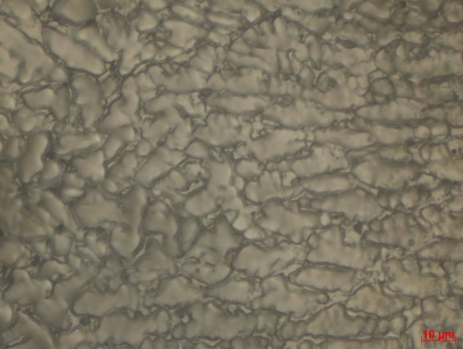

*(c) (d)*

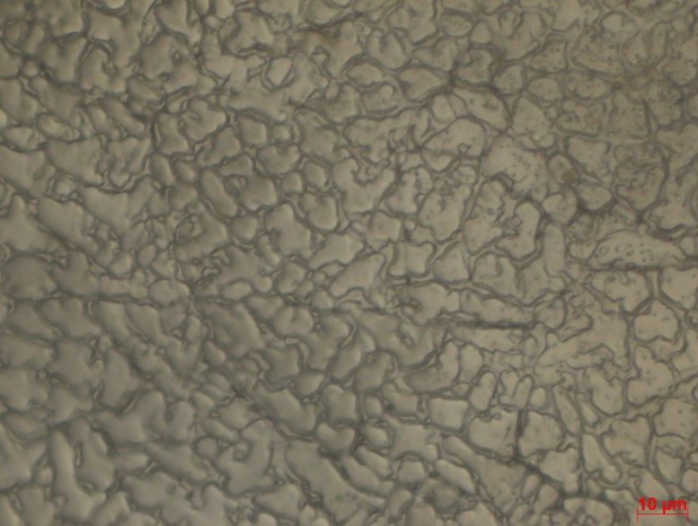

*(e)*

*Fig. 24: Microstructures (a) At 400°C (b) At 600°C (c) At 800°C (d) At 1000°C (e) At 1150°C*

|  |  |
| --- | --- |
| **Temperature** | **Grain Diameter (μm)** |
| 400°C | 5.93 |
| 600°C | 6.93 |
| 800°C | 7.48 |
| 1000°C | 12.45 |
| 1150°C | 8.82 |

*Table 13: Grain Diameter at different Temperatures*

Chapter 5

Analysis

**5.1 Peak Shift v/s Temperature**

*Figure 26* illustrates the peak shift variation with temperature for (111), (200), and (220) peaks of DED_316L. The peak shift is calculated by considering the peak position of 25°C calculated for that respective sample as reference.



*Fig. 25: Combined XRD Graph*

*Fig. 26: (a) (111) Peak*

*Fig. 26: (b) (200) Peak*

*Fig. 26: (c) (220) Peak*

**Observations**

* Peak Shift increases with increasing peak number at const. temperature.
* Peak Shift increases with increasing temperature till 1000°C for any peak.

**Reason for Peak Shift at elevated temperatures:**

A crystal does not have its atoms arranged on a perfectly regular lattice extending from one side of the crystal to the other. Instead, the lattice is broken up into several tiny blocks, each slightly disoriented from one another. This is demonstrated in figure 17. Let’s say *“*𝛼*”* is the maximum disorientation angle.



*Fig. 27: Representation of an actual lattice showing disorientation [6].*

If *“*𝜃*”* is the incident beam angle, diffraction occurs around *“*𝜃+ 𝛼.*” [6]*

*“*𝛼*”* decreases at elevated temperatures due to *“*polygonization*, [17]”* thus causing peak shift towards left side.

**5.2 Lattice Parameter v/s Temperature**

From Bragg’s Law,

The lattice parameters for all three peaks were calculated using the described method, and their average values are presented in *Figure 28*.

*Fig. 28: Lattice Parameter v/s Temperature*

**Observations**

* Lattice Parameter increases with increasing temperature.

**5.3 Grain Size v/s Temperature**

From the values reported in *Section 4.5, Figure 29* illustrates the variation of grain diameter with temperature.

*Fig. 29: Grain Diameter v/s Temperature*

**5.4 Strain v/s Temperature**

From the values reported in *Section 4.4, Figure 30* illustrates the variation of strain with temperature.

*Fig. 30: Strain v/s Temperature*

**Observations**

* Strain decreases with increasing temperature due to the relief of internal stresses [17].

Internal strain in materials decreases with heat treatment because heating allows atoms to gain energy, which facilitates their movement and rearrangement into more stable positions [18]. This relieves internal stresses formed during processes like machining, welding, or additive manufacturing.

At higher heat treatment temperatures, materials experience more significant atomic diffusion and recrystallization. This leads to a more effective reduction in residual stresses, as dislocations can annihilate or rearrange more efficiently, resulting in greater stress relief.

**5.5 Dislocation Density v/s Temperature**

From the values reported in *Section 4.4, Figure 31* illustrates the variation of dislocation density with temperature.

*Fig. 31: Dislocation Density v/s Temperature*

**Observations**

* Dislocation density decreases with increasing temperature.

Dislocation density decreases during high-temperature annealing because the heat provides energy for atoms to move [17], allowing dislocations to rearrange, annihilate, or merge. This process reduces the overall dislocation count, leading to the recovery of the material, resulting in a lower dislocation density.

**5.6 Hardness v/s Temperature**

*Fig. 32: Hardness v/s Temperature*

**Observations**

* Strain decreases with increasing temperature due to decrease in dislocation density.

Hardness decreases with a reduction in dislocation density because dislocations are obstacles to the movement of other dislocations [17]. A high dislocation density means more barriers, making the material harder and stronger [18]. When dislocation density decreases, fewer obstacles are present, allowing atomic planes to slip more easily under stress, resulting in reduced hardness.

**Conclusion**

This project focused on the comprehensive analysis of the microstructural and mechanical properties of 316L steel fabricated using Directed Energy Deposition (DED) under elevated temperature conditions. By conducting X-ray Diffraction (XRD) analysis at temperatures ranging from room temperature to 1150°C, we successfully evaluated the variation of several key parameters, including lattice parameter, grain size, strain, dislocation density, and Vickers hardness.

The study revealed that the lattice parameter increased with temperature, indicating thermal expansion, while the grain size showed a significant increase due to grain growth till 1000°C for the mentioned heat treatment conditions. This grain growth contributed to a reduction in strain and dislocation density, suggesting improved lattice integrity and stress relaxation. The observed decrease in dislocation density and strain with increasing temperature highlighted the material's capacity to withstand thermal exposure, which is critical for high-temperature applications.

Moreover, the Vickers hardness measurements showed a decline with rising temperatures, correlating with the observed grain growth and reduced dislocation density. The findings indicate that while 316L steel exhibits good thermal stability, its hardness decreases at higher temperatures, which is an important consideration for its application in environments subjected to thermal cycling.

Overall, this project contributes to the understanding of the thermal behaviour of additively manufactured 316L steel, providing valuable insights for optimizing its performance in applications such as aerospace, automotive, and power generation industries, where materials are exposed to varying thermal conditions.

**Future Scope**

**Advanced Characterization**: Further studies using advanced techniques like TEM and EBSD can provide deeper insights into microstructural changes, dislocation behaviour, and residual stress distribution.

**High-Temperature Applications**: Expanding the temperature range beyond 1150°C can explore the material's performance for extreme environments, especially for aerospace and power generation applications.

**Additive Manufacturing Optimization**: Investigating different post-processing treatments, such as annealing or HIP (Hot Isostatic Pressing), could optimize mechanical properties and reduce residual stresses in DED-manufactured components.

**Computational Modelling**: Integrating molecular dynamics simulations or finite element modeling can predict residual stress and dislocation behaviour under various thermal conditions, enhancing the understanding of material performance.

**References**

1. Aleksandra L. Vyatskikh , Xin Wang , James Haley , Baolong Zheng , Lorenzo Valdevit, Enrique J. Lavernia , Julie M. Schoenung, “Residual stress mitigation in directed energy deposition”, Materials Science & Engineering A
2. Ian, David, and Brent. Additive Manufacturing Technologies. Springer, 2015.
3. Lenntech. (n.d.). Stainless Steel 316L Properties
4. Shenliang Yang , Adam T. Clare , Chris Bennett , Xiaoliang Jin, “Informing directed energy deposition strategies through understanding the evolution of residual stress”, Additive Manufacturing
5. Prime, R. B., Bair, H. E., Vyazovkin, S., Gallagher, P. K., & Riga, A. Thermogravimetric analysis. In Thermal analysis of polymers. Wiley.
6. B.D. Cullity, S.R. Stock, Elements of X-Ray Diffraction, Third Edition, Pearson New International, 2014.
7. Khan, H., Yerramilli, A. S., D’Oliveira, A., Alford, T. L., Boffito, D. C., & Patience, G. S. (2019). Experimental methods in chemical engineering: X-ray diffraction spectroscopy—XRD. Canadian Journal of Chemical Engineering.
8. Bunaciu, A. A., Udriştioiu, E. gabriela, & Aboul-Enein, H. Y. (2015). X-Ray Diffraction: Instrumentation and Applications. Critical Reviews in Analytical Chemistry, 45(4), 289–299.
9. Paterson, M. S. (1952). X-ray diffraction by face-centered cubic crystals with deformation faults. Journal of Applied Physics, 23
10. Warren, B. E., & Averbach, B. L. (1952). The separation of cold-work distortion and particle size broadening in X-ray patterns. Journal of Applied Physics, 23
11. Williamson, G. K., & Hall, W. H. (1953). X-ray line broadening from field aluminium and wolfram. Acta Metallurgica.
12. G. K. Williamson & R. E. Smallman (1956): III. Dislocation densities in some annealed and cold-worked metals from measurements on the X-ray debye-scherrer spectrum, Philosophical Magazine, 1:1, 34-46
13. Wolfram Research. (n.d.). Gaussian function. In Wolfram MathWorld.
14. Origin Lab Corporation, Origin Pro 2024b
15. G. Dini , R. Ueji , A. Najafizadeha, S.M. Monir-Vaghefia, “Flow stress analysis of TWIP steel via the XRD measurement of dislocation density”, Materials Science and Engineering A
16. R.E. Smallman, K.H. Westmacott, Philos. Mag. 2 (1957) 669–683
17. Robert E. Reed-Hill, Reza Abbaschian, Physical metallurgy principles, 1994
18. William F. Hosford, Physical Metallurgy, 2005